AI绘画关键词
序  号 | 图集名称 | 中文关键词 | 英文关键词 | 成品效果样板图
1 | 海面星空  山水画 | 一个真实的摄影山水画与无与伦比的现实，广阔的视野，在海面上，星星，阳光，冬天，光效果，现实主义，丹尼斯萨拉欣，艺术站 | A real photographic landscape painting with incomparable reality,Expansive view,On sea surface,Stars,Sunshine,Winter,Light effect,Realistic,Denis sarazhin,artstation | 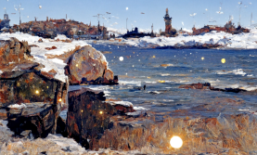
2 | 岛上樱花 | 一幅美丽的画，广阔的视野，在岛上，樱花，莲花，巨大的波浪，蘑菇，早晨，光效果，清晨，夏天，虚幻引擎，Beeple,Ayu，艺术站 | A beautiful painting,Expansive view,In island,Cherry blossomo,Lotus,Huge waves,Mushrooms,Morning,Light effect,Early morning,Summer,Unreal engine,Beeple,Ayu,artstation | 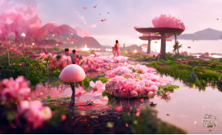
3 | 冬天  海上红梅 | 一幅美丽的画，广角，在海面上，多云，下雪，红梅，早晨，冬天，童话，超写实的画风，杉本博，Ayu，艺术站 | A beautiful painting,Wide angle,On sea surface,Cloudy,Snowfall,Red plum blossoms,Morning,Winter,Fairy tale,Super realistic painting style,Hiroshi sugimoto,Ayu,artstation | 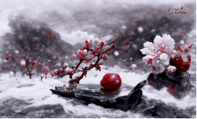
4 | 城堡  海浪  山水画 | 一幅真实的摄影山水画，无可比拟的现实，广阔的视野，中国龙，巨大的波浪，星星，宁静的风景，城堡，夜晚，童话，体积照明，Zbrush中央，Lee madgwick，艺术站 | A real photographic landscape painting with incomparable reality,An expansive view of,Chinese dragon,Huge waves,Stars,Serene landscape,Castle,Evening,Fairy tale,Volumetric lighting,Zbrush central,Lee madgwick ,artstation | 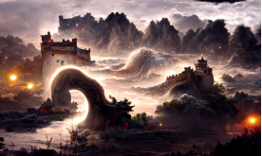
5 | 桥、金叶、火花 | 史诗cg哑光绘画，微距离拍摄，在山上，桥，桥，金叶，火花，晚上，冬天，高清图片，哑光绘画，maya渲染，Thomas kinkade,James gurney，艺术站 | An epic cg matte painting,Macro shot,On mountains,Bridge,Bridge,Gold leaves,Fire flowers,Evening,Winter,High-definition picture,Matte painting,Rendered in maya,Thomas kinkade,James gurney,artstation | 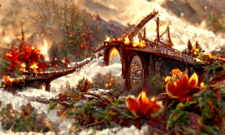
6 | 降雪的梅花城堡 | 史诗cg哑光绘画，尽你所能，在岛屿，城堡，红色的梅花，降雪，蝴蝶，明亮的风格，夏天，在cinema4d渲染，James gurney,Krenz cushart，艺术站 | An epic cg matte painting,As far as eye can see,In island,Castle,Red plum blossoms,Snowfall,Butterfly,Bright style,Summer,Rendered in cinema4d,James gurney,Krenz cushart,artstation | 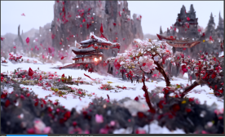
7 | 海底蘑菇 | 一幅美丽的画，尽你所能，在海底，蘑菇，月亮，傍晚，空地，在cinema4d中渲染，John howe,Thomas kinkade,artstation | A beautiful painting,As far as eye can see,At the bottom of the sea,Mushrooms,Moon,Evening,Clearing,Rendered in cinema4d,John howe,Thomas kinkade,artstation | 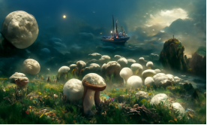
8 | 冬天的玫瑰花园 | 一幅美丽的画，冬天，晨光，远处的湖，大城堡，粉红色的云，红色的玫瑰花园，阳光，童话，灯光效果，幻想，托马斯·金凯德，虚幻引擎，超写实风格，4K，超广角，艺术站，梦幻，浪漫 | A beautiful painting of Winter, morning light, distant view of the lake, large castle, pink clouds, red roses garden, sunshine, fairy tale, lighting effects, fantasy, Thomas Kincaid, Unreal Engine, hyperrealistic style, 4K, ultra wide Angle, art station, dreamlike, romantic | 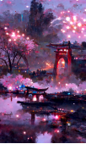  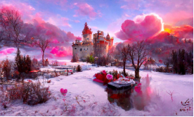
9 | 樱花湖  烟花夜景 | 烟花，夜灯，拱桥，山谷中的中国建筑，雨，淡蓝色的天空，赛博朋克灯光效果，樱花，湖泊，云，WLOP，童话，梦想，广阔的视野，由Greg Rutkowski和James Gurney,vary,4K, artstation. | fireworks, night light,arch bridge,Chinese buildings in vally, rain，Light blue sky，cyberpunk light effect，cherry blossoms,lake, cloud, WLOP,Fairy tale,Dream，expansive view，by Greg Rutkowski and James Gurney,vary，4K，artstation.
10 | 早晨的玫瑰花园 | 史诗CG哑光绘画，广阔的视野，早晨，天空，玫瑰花园，云，雾，艺术站，高清图片，虚幻引擎，高清图片。 | An epic CG matte painting,expansive view, Morning, sky, rose garden, clouds, mist,artstation, high-definition picture, Unreal Engine, high-definition picture. | 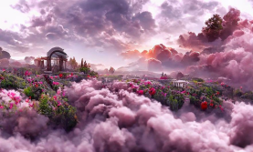
11 | 玫瑰长城 | 史诗cg哑光绘画，微距拍摄，在花园，多云，红玫瑰，桃花，长城，星夜，清晨，机械，清理，虚幻引擎，Lee madgwick ,Lee madgwick ,艺术站 | An epic cg matte painting,Macro shot,In garden,Cloudy,Red rose,Peach blossoms,Great Wall,Starry night,Early morning,Mechanical,Clearing,Unreal engine,Lee madgwick ,Lee madgwick ,artstation | 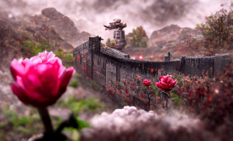
12 | 不祥天空  红玫瑰 | 一个真正的摄影山水画，广阔的视野，不祥的天空，红玫瑰，明亮的风格，光效果，清除，清除，虚幻引擎，托马斯金凯德，艺术站 | A real photographic landscape painting,Expansive view,Ominous sky,Red rose,Bright style,Light effect,Clearing,Clearing,Unreal engine,Thomas kinkade,artstation | 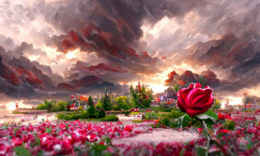  12  不祥天空  红玫瑰  一个真正的摄影山水画，广阔的视野，不祥的天空，红玫瑰，明亮的风格，光效果，清除，清除，虚幻引擎，托马斯金凯德，艺术站  A real photographic landscape painting,Expansive view,Ominous sky,Red rose,Bright style,Light effect,Clearing,Clearing,Unreal engine,Thomas kinkade,artstation
13 | 玫瑰花园 | 一个美丽的红玫瑰花园，星夜，宁静的风景，沉默，由beeple，杉本博司，艺术站 | A beautiful red rose garden, starry night，serene landscape, silcence, by beeple，Hiroshi Sugimoto，artstation |  | 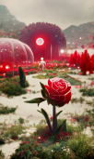
14 | 玫瑰教堂1 | 清晨，金色的玫瑰在天空中盛开，粉红色的云在空中漂浮，地面上有一座教堂，Ivan Aivazovsky的超现实主义作品，大体量照明，在艺术网站Trending | Golden roses were blooming in the sky at dawn, pink clouds were floating, and there was a church on the ground,ultra-realistic,by Ivan Aivazovsky ,in volumetric lighting, Trending on artstation | 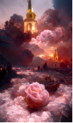 | 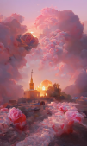
15 | 玫瑰教堂2 | 黎明时分，粉红色的玫瑰在天空中盛开，粉红色的云漂浮着，很多小粉红玫瑰，地面上有一个金色的教堂，超逼真的，在体积照明中，上面+超广角，Thomas Kinkade，在artstation上的趋势，4k | pink roses were blooming in the sky at dawn, pink clouds were floating,lots of little pink roses, and there was a golden church on the ground,ultra-realistic ,in volumetric lighting, above+super wide Angle, Thomas Kinkade,Trending on artstation,4k | 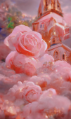 | 
16 | 玫瑰宫殿 | 在晨曦中，湖边有一座宫殿。玫瑰花园充满了玫瑰，周围是云雾，它是浪漫和梦幻的，超大的场景，托马斯金凯德，超广角，高清画面，细节，在艺术工作站渲染 | In the morning light, there is a palace by the lake. The rose garden is full of roses,surrounded by clouds and mist, It is romantic and dreamy ,super large scene,Thomas Kincaid,ultra wide Angle,high-definition picture,detailed,rendered in artstation
17 | 玫瑰城堡1 | 在晨曦中，湖边有一座城堡。玫瑰花园充满了玫瑰，周围是云雾，它是浪漫和梦幻的，超大的场景，托马斯金凯德，超广角，高清画面，细节，在艺术工作站渲染 | In the morning light, there is a castle by the lake. The rose garden is full of roses,surrounded by clouds and mist, It is romantic and dreamy ,super large scene,Thomas Kincaid,ultra wide Angle,high-definition picture,detailed,rendered in artstation | 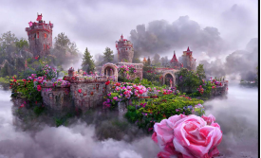
18 | 玫瑰城堡2 | 远处有一座城堡，笼罩在云中，城堡上长着粉红色的玫瑰，草地上覆盖着粉红色的玫瑰，俯瞰超宽的角度，Thomas Kinkade,Trending on artstation | There is a castle in the distance, shrouded in clouds, long pink roses on the castle, the grass is covered with pink roses, overlooking the super wide Angle, Thomas Kinkade,Trending on artstation |  | 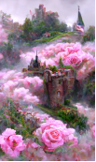
19 | 玫瑰城堡3 | 远处有一座城堡，笼罩在云中，城堡上长着粉色的玫瑰，草地上覆盖着粉色的玫瑰，上面+超广角，Thomas Kinkade, artstation上的趋势 | There is a castle in the distance, shrouded in clouds, long pink roses on the castle, the grass is covered with pink roses, above+super wide Angle, Thomas Kinkade,Trending on artstation |  | 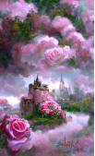
20 | 甜品屋 | 一幅漂亮的粉黄多层甜品室，黄色的灯光，许多大大小小的甜点散落在云中，许多层的云，梦幻的颜色，甜蜜的气氛，Thomas Kinkade, Ross Tran，超详细，4k，在艺术站趋势。 | A beautiful painting of Pink yellow multi-layer dessert room, yellow light, many large and small desserts scattered in the clouds, many layers of clouds, dreamlike color, sweet atmosphere,Thomas Kinkade, Ross Tran,ultradetailed, 4k, Trending on artstation. |  | 
21 | 桃花源 | 无边的桃花潭水深千尺，许多桃树和桃花覆盖了整个清澈的湖面，笼罩在云雾中，粉红色的云漂浮在天空中，上面+超宽角度，Thomas Kinkade, Artstation的趋势 | The boundless peach blossom pool is thousands of feet deep, and many, many peach trees and peach blossoms cover the entirecrystal clear lake, shrouded in clouds and mist, and pink clouds float in the sky, above+super wide angle Thomas Kinkade, trends on Artstation
22 | 桃花源  中国宫殿 | 一张张美丽的画描绘了中国宫殿的美景，无边无际的桃花池深达数千英尺，许多许多的桃树和桃花覆盖了整个晶莹剔透的湖泊，笼罩在云雾中，粉红色的云漂浮在天空，上面超宽的角度，托马斯金凯德，梦幻，4K，浪漫，Artstation的趋势 | A beautiful painting of a beautiful view of the Chinese palace， The boundless peach blossom pool is thousands of feet deep, many many peach trees and peach blossoms cover the entire crystal clear lake, shrouded in clouds and mist, pink clouds float in the sky, above ultra-wide angle, Thomas Kinkade, dreamlike, 4K, romantic, trends on Artstation | 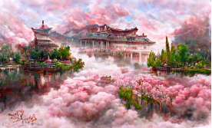
23 | 梦想玫瑰城堡 | 清晨，日出，阳光，梦想城堡，瀑布，云，很多小玫瑰，上面+超宽的角度，Thomas Kinkade，在artstation上的趋势 | Morning, sunrise, sunshine, dream castles, waterfalls, clouds, lots of little roses, above+super wide Angle, Thomas Kinkade,Trending on artstation | 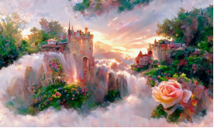
24 | 海上玫瑰 | 夏天的一天，粉红色和白色的云在海上，詹姆斯格尼，一场厚厚的玫瑰，cgsociety，变化，由麦克斯韦尔，超宽拍摄，高清图片，在艺术工作站渲染 | summer day, pink and white clouds over the sea，James Gurney，a field thick with roses，cgsociety，vary，by Maxwell，ultrawide shot，high-definition picture, rendered in artstation | 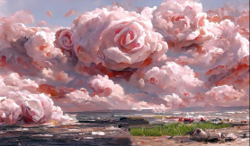
25 | 沙漠玫瑰 | 夏天的一天，撒哈拉沙漠上空的粉色和白色的云，詹姆斯·格尼，一大片玫瑰，cgsociety，变化，由麦克斯韦尔，超宽拍摄，高清图片，在艺术工作站渲染。 | summer day, pink and white clouds over the Sahara desert，James Gurney，a field thick with roses，cgsociety，vary，by Maxwell，ultrawide shot，high-definition picture, rendered in artstation. |  | 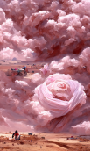
26 | 爱情之路  -  楼梯上的天空玫瑰 | 夏天的一天，粉红和白色的云在海上，楼梯上的云，詹姆斯格尼，一个厚厚的玫瑰，cgsociety，变化，由麦克斯韦，超宽拍摄，高清图片，在艺术工作站渲染。 | summer day, pink and white clouds over the sea, stairs up to clouds， by James Gurney，a field thick with roses，cgsociety，vary，by Maxwell，ultrawide shot，high-definition picture, rendered in artstation. |  | 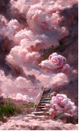
27 | 黎明的粉色玫瑰瀑布 | 黎明，天空中的城市，金色的云，粉红色的玫瑰瀑布，托马斯·金凯德，罗斯·陈 | Dawn, city in the sky, golden clouds, pink rose waterfall，Thomas Kinkade, Ross Tran |  | 