序号
中文关键词
英文关键词
图例
At night sky, the beach is covered with blue and green
fluorescence, the huge moon, elf light, stars, facula, the sea
with fluorescence, the shining golden beach, the starry sky with
moonlight, Michael james Smith's matte painting, reflection, cg
rendering, volume light, space art, bioluminescence, unreal engine
5, magic of light, unreal engine rendering, super wide angle,
super wide angle, high definition. --ar 9:16
1
A high-definition CG rendering of a dark rose forest, a rose path,
long floating red roses on the ground, fireflies, luminous ovules,
light effects, snowstorm style art trendsmagical light fognight
timelow light volumetric lightingue4 zbrushmarmostt toolbag HD --
ar 9:16
2
3
4
5
6
Blue sky, blue sea, pink beach, many pink roses spread on the
beach, which is very romantic.HD --ar 9:16
Lycoris radiata in the sky is red, and its petals are transparent.
It is as deep as the sea. It can feel loyalty and purity.
Love, mysterious light, soft light。HD --ar 9:16
Red Rose. Petals as deep as sea water, crystal clear grass,
frozen in ice cubes, you can feel the loyalty and purity of love,
high details and bigDepth of Field, 1080 P ,HD, --ar 9:16
There are many round gold coins in the pool, beside which there
are golden lotus flowers,frozen roses, and 4k 7x 1 plant roses at
night make the room full of romantic.HD --ar 9:16

A Panoramic Hanging Garden Rose World in an Alien Transparent
Glass Bottle, Castle, Rose Petals Flying, Romance, Dream, Greg
Ratkowski, Night, Red Rose Pavilion, Art Station Trends, Bright
Lighting, Smoke, Wood Support, UE4, HD, Lighting, Winter AUV,HD, -
-ar 9:16
7
At night,moon,There are several colored flowers nearby. There are
many transparent dew on the transparent petals. They are blooming
on the bank. There is a winding brook river. In the distance, the
valley is shrouded in clouds. The village is dimly seen. The gray
background，8k,HD --ar 9:16
8
A panoramic sky garden rose world in a special-shaped transparent
glass bottle, castle, roses, petals are flying, romance, dream,
Greg lat Kosky, night, red rose Pavilion, art station trend,
bright lights, smoke, wood support, UE4, HD, lighting, winter, AUV
--ar 9:16
9
the most beautiful golden tree, There is a golden rabbit under the
tree 241HD --ar 9:16
10
11
12
On a small mountain peak, there is a golden spring gushing upward.
The spring water gathers into a stream, surrounded by many flowers
and colorful colors lighting effect, CG rendering the dark skyHD -
-ar 9:16 --iw 10
Presented by HD CG, Black Rose Desert Rose Path, Blue Rose,
Firefly, Domino Vule Long Floating, Music Lighting, Rainbow Light
EffectFruitLight Fog Night Time Lightning Roll Lighting Kit of Art
Trends in a Light Style,HD, --ar 9:16

Gorgeous crystal shop white church, red rose, lighting effect,
romance, CG rendering European style, overlooking, fairy tale,
rose surround, lighting effect, party, super detail, 4K, unreal
engine, unreal cloud, HD --ar 9:16
13
14
15
16
17
18
Ancient ship,Many rose,A few roses,clouds, ultra wide shot,
atmospheric, hyper realistic, 8k, epic composition, cinematic,
octane render, artstation landscape vista photography by Carr
Clifton & Galen Rowell, 16K resolution, Landscape veduta photo by
Dustin Lefevre & tdraw, 8k resolution, detailed landscape painting
by Ivan Shishkin, DeviantArt, Flickr, rendered in Enscape,
Miyazaki, Nausicaa Ghibli, Breath of The Wild, 4k detailed post
processing, artstation, rendering by octane, unreal engine --ar
9:16 --iw 1 --test --creative
Palace half immersed in water blue lake, underwater trees, snow,
roses, fairyland, dreamy, unreal engine, ultra clear, 8K, extreme
rendering, high detail, light and shadow effects, epic, wide-angle
--ar 9:16 --q 2
beautiful portrait of realistic Aerith --ar 2:3 --testp --upbeta
Gorgeous crystal shop white church, red rose, lighting effect,
romance, CG rendering European style, overlooking, fairy tale,
rose surround, lighting effect, party, super detail, 4K, unreal
engine, unreal cloud, HD --ar 9:16 --test --creative
beautiful female wizard short blond hair, short beard, full body,
detailed whitish armor, intricate filigree metal design, magic
halo, studio light, opal, silk, mist, photorealistic, octane
render, unreal engine, hyper detailed, volumetric lighting,
romantic pastel colors, hdr, octane render, 4k, 8k --ar 2:3 --
video --testp
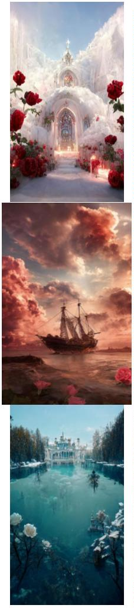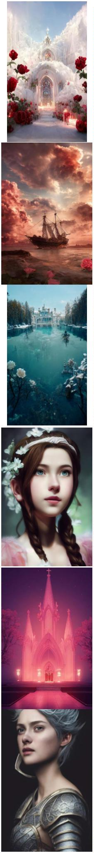

Pixar Style, Tiny cute and adorable cat dressed in raincoat, in
the rain, anthropomorphic, 8k, portrait, --ar 9:16 --s 5000 --
testp
19
20
21
22
23
24
cute anthropomorphic bunny in a kimono under cherry blossoms in
pixar style, octane render --testp --ar 2:3
ultra wide photo, overcast grey sky rainy clouds, Icelandic
landscape, field of moss, octane, photo realism, realistic,
extreme detail --test --creative --ar 2:3
Tiny cute and adorable monkey dressed in large streetwear clothing
, wearing sneakers , anthropomorphic , studio lighting, fashion
photography --ar 9:16 --testp --video
succulent terrarium in a glass jar, photorealistic, HDR, dynamic
lighting, unreal engine, octane render, dynamic composition --
testp --creative --ar 2:3
anthropomorphic cute baby cream Pomeranian as Elvis Presley,
hairstyles like Elvis Presley, standing, singing and dancing like
a rockstar, on the stage, with microphone, anthropomorphic, raving
fans in background, 8k --ar 2:3 --test
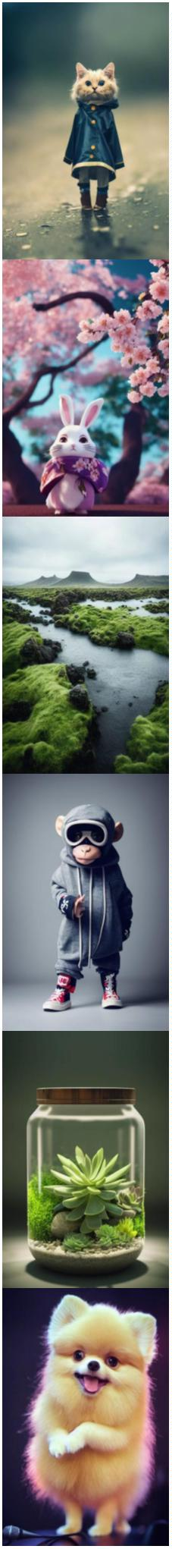

queen of the wind, long hair flying in the wind, cinematic light,
dramatic --ar 2:3 --test --creative
25
26
27
28
29
30
Beautiful Woman dissolving into colorful liquid oil paint, wind,
cinematic lighting, photo realistic, by karol bak --ar 2:3 --testp
--upbeta
beautiful female form with bursting floral head, roses, peonies,
songbirds in flight, morning glories, ethereal wisps of swirling
color --test --ar 2:3 --upbeta
cute baby white fox dressed as snow Queen, Pixar style,
anthropomorphic , Slept in the garden, 4k, trending on artstation,
Gorgeous,ultra wide angle, 4K, --ar 9:16
cute baby white fox dressed as snow Queen, Pixar style,
anthropomorphic , Slept in the garden, 4k, trending on artstation,
Gorgeous,ultra wide angle, 4K, --ar 9:16 --testp --upbeta
一个中国古代美人的红色背影，
一个奇怪的怪物，一个圆形的光 The back of an ancient Chinese beauty in red, a strange monster, a
晕，星空，CG渲染，体积光，太 round halo, a starry sky, CG rendering, volume light, space art,
空艺术，虚幻引擎5，超广角，高 unreal engine 5, ultra wide angle, high definition --ar 9:16
分辨率——ar 9:16
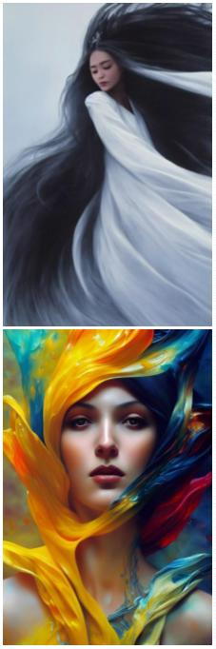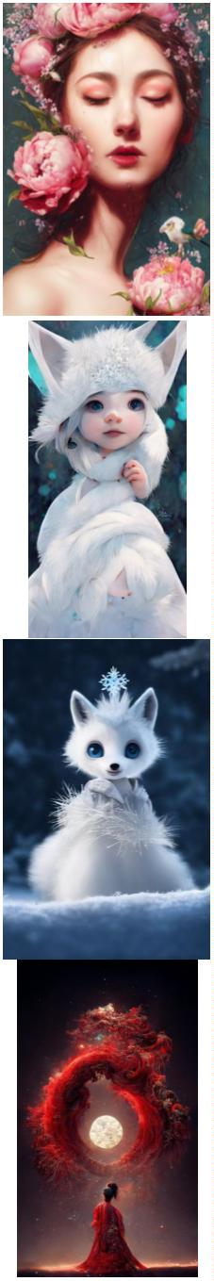

一头中国元素的古龙，龙的颜色
是金色与红色搭配，龙的特征明
显，超细节，CG渲染，星空，空
间艺术，虚幻引擎5，高清晰度，
超广角，8k --ar 9:16
An ancient dragon with Chinese elements. The color of the dragon
is gold and red. The characteristics of the dragon are obvious,
super detail, CG rendering, starry sky, space art, unreal engine
5, high definition, ultra wide angle, 8K --ar 9:16
31
On a windy night in a month, a small yard was planted with peach
blossom trees, a group of butterflies were dancing, and four
people were sitting on the table eating moon cakes. There were
peach blossoms in the moon and cotton clouds in the air. The
picture was very beautiful. The wide-angle view was 8K,HD --ar
9:16
32
This is a beautiful picture, cherry blossom forest, Mid-Autumn
Festival, the white moon slowly rising from the waterfall,dream,
gems, smoke, Movie HD, lots of detail, surrealism, magic, U Unreal
Engine, lighting--hd --ar 9:16 --testp
33
blue sea, blue sky and white beach, scattered pink roses. Spread
beach, a champagne colored broken diamond fine twinkling rose path
leading to Crescent Bay, is surrounded by several colorful colored
stones, panoramic view, ultra wide view, and beach in light blue
and pink sky. Dream engine, epic rendering, Ultra HD, ultra wide
angle, art station,4K.HD --ar 9:16
34
On a summer night, there is a light blue starry sky, and a train
has passed on the ground, surrounded by pink flowers and green
plants, lighting effects, starlight, fairy tales,by Makoto Shinkai
and Claude Monet,trending on behance,8K HD --ar 9:16
35
Super wide angle view, red rose icebulerosegarden + beautiful
paintings in the factory area, tall factory with many iron frames,
iron nets, factory lighting, Greg ratkowski, night, a little red
rose on the iron frame, art station trend, low light, smoke, steel
support, volume lighting, UE4, ZBrush, marmoset Kit HD --ar 9:16 -
-iw 10
36
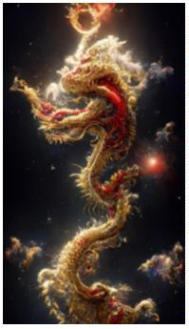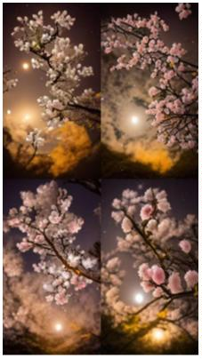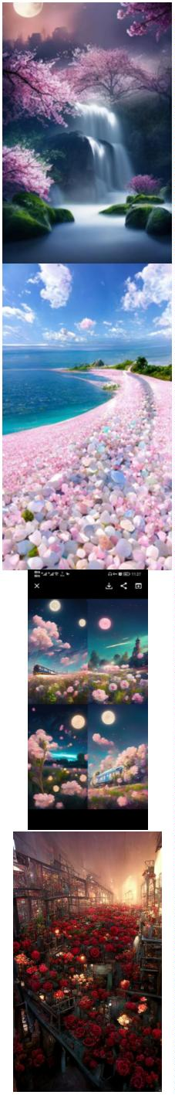

house floating in the air, cotton candy clouds, watermelon clouds,
small flowers, grass, flowers,lake, light green background, dream,
fairy tale,HD --ar 9:16
37
38
39
40
41
42
There are many green pointed tender leaves on the flower branches,
many crystal clear lavender flowers, and translucent petals curled
around its wet flower center. There are crystal dew on the
flowers. The hazy gray blue background is clear, and several
transparent snowflakes are falling,HD --ar 9:16
This is a beautiful picture, cherry blossom forest, Mid-Autumn
Festival, the white moon, slowly rising from the sea, dream，8K
,HD --ar 9:16
cute white lion in black plate armor and long white hair with red
splatter, dark cloud background, symmetrical face, volumetric
lighting, half body, legendary, epic, character design, cover art,
singer sargent, naruto, Diego Velázquez, fantasy, illustration,
highly detailed
Tempest Creation, silver angel of echoes and endless sound, god-
teir, god-level, god-like beauty
constellation echo, god-tier lorn, king of endless sound,
commander of motion, the gatekeeper of time, epic, cinematic
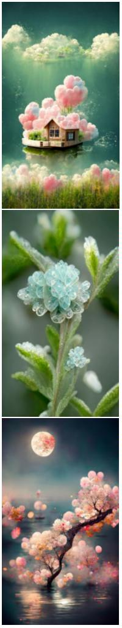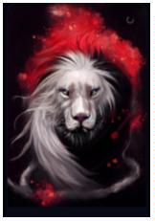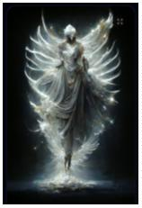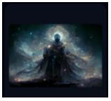

Margot Robby with pink katana, crazy, night light, city, fabric,
4K, realistic, cgi, beautiful, unreal engine, detailed, intricate
details, dramatic, photorealistic, beautiful, cinematic lighting
43
44
45
46
47
48
Oriental myth, Chinese dream Dununhuang Flying sky, super
delicate, crystal noble Gorgeous tulle light clothes, behind a
pair of translucent gorgeous white wings, huge moon,China
Palace,soft light, gold wirvire Flying, white feathers, mystery,
gems, smoke, Movie HD, lots of detail, surrealism, magic, U Unreal
Engine, lighting--hd --ar 9:16
Oriental myth, Chinese dream Dununhuang Flying sky, super
delicate, crystal noble Gorgeous tulle light clothes, behind a
pair of translucent gorgeous white wings, soft light, gold wirvire
Flying, white feathers, mystery, gems, smoke, Movie HD, lots of
detail, surrealism, magic, U Unreal Engine, lighting--hd --ar 9:16
A tree is covered with gold coins. The leaves are gold and the
flowers are gold. There are many beautiful golden wild flowers
under the tree. on an island in the center of a lake, dreamy
mist，It is resplendent, dreamy, light effect, 4K..HD --ar 9:16
Pixar Style, Tiny cute and adorable bunny adventurer dressed in
medieval armour , jean - baptiste monge , anthropomorphic ,
dramatic lighting --ar 2:3 --testp
cyan chinese dragon fantasy, intricate, elegant, highly detailed,
digital painting, artstation, concept art, matte, sharp focus,
illustration by greg rutkowski, john howe, 8k --aspect 9:16 --test
--creative
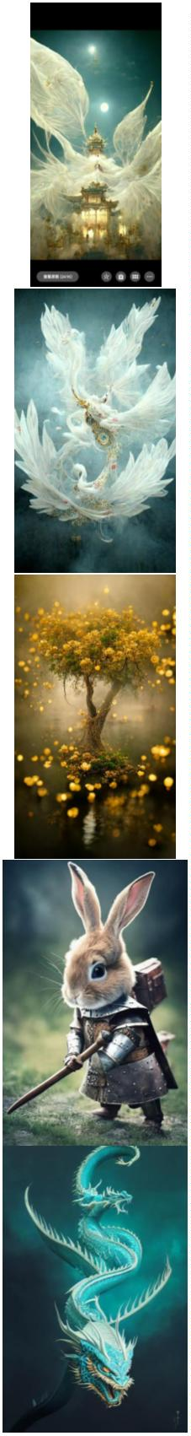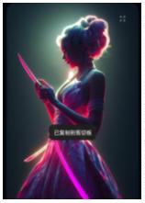

ethereal absinthe fairy with intricate glass wings, magical forest
background, will-o-the-wisp, mystical, eerie, dreamlike, glim
light --ar 2:3 --testp --s 1500
49
50
51
52
53
54
a portrait of an ethereal tulip goddess, sunny light, fresh
feelings, photorealistic, in the style of Tom Bagshaw and Anna
Dittmann and Monia Merlo --test --creative --ar 2:3
adorable border collie laying on a colorful blanket, realistic,
cinematic lighting, award winning photo, 80mm lens --testp --
creative --ar 2:3 --video
a male witch made of sand and foam wearing ocean haute couture,
blue jupiter gas swirls as sand, swirling sand and foam, blue foam
swirling,marble swirls, textured as sand, haute couture, dust and
foam in the background --ar 9:16 --test --creative --upbeta
beautiful female form with bursting floral head, roses, peonies,
songbirds in flight, morning glories, ethereal wisps of swirling
color --test --ar 2:3 --upbeta** - Upscaled (Beta)
beautiful woman, long gray and wavy hair, lacy black dress, silver
jewelery, complex details, very realistic, art by Ben Enwonwu and
karol bak and tom bagshaw --ar 9:16 --test --creative
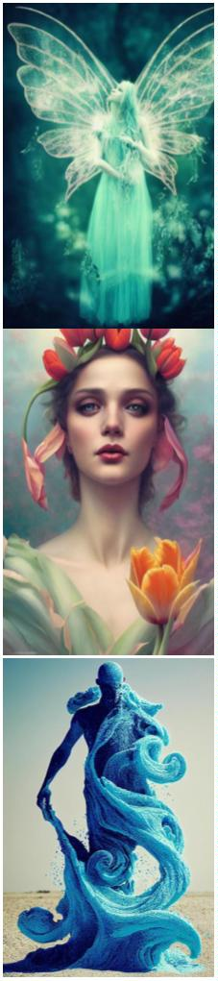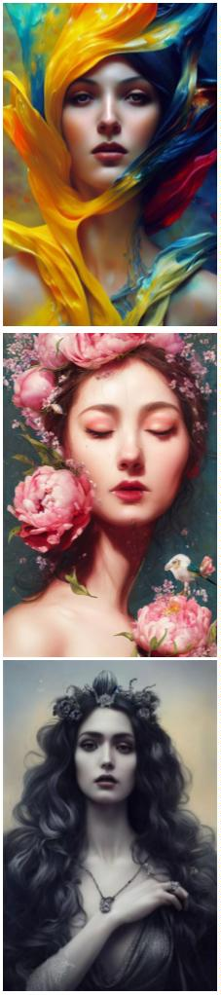

medieval male peasant with asian elder face, working in the
fields, tattered clothing, concentrated expression, tanned skin,
emotive eyes, dynamic pose, Alphonse Mucha, Tom Bagshaw, painted
by artgerm, krenz cushart, digital painting, highly detailed, art
nouveau style, 3, --no hands --ar 2:3 --test --creative
55
56
57
58
59
60
A meta-universe sci-fi game hall, from Ready Player One,
cyberpunk style, in front of the hall with a big screen, service
desk, futuristic, technological, blockchain, HD, rich details --ar
9:16
A beautiful huge cliff, ancient Chinese architecture, rainbow
waterfall, water mist, soft light, crystal texture of clouds,
fairy tale, dream, fluorescent, volume light matte painting, below
the waterfall is a huge lake, green water, Thomas kinkad and
Taylor Edlin, popular on cgsociety, 8K, volume light --ar 9:16
A ultra-realistic CG rendering of Ancient China,Lake, bridge, Plum
blossom,mysterious loneliness, withering, loneliness, a bright
moon, reflected in the water,A ultra-realistic CG rendering--iw 10
--ar 9:16
Fantasy, Black background, HD Mid-Autumn Festival Chinese Elegant
Peony+tranquility aestheticism+high details, soft moonlight, soft
colors, soft lights,8k new happiness, deep details,distinct levels
of detail,high picture quality,high definition and new Huan
renderin,8K HD --ar 9:16
Fantasy, Black background, HD Mid-Autumn Festival Chinese Elegant
Peony+tranquility aestheticism+high details, soft moonlight, soft
colors, soft lights,8k new happiness, deep details,distinct levels
of detail,high picture quality,high definition and new Huan
renderin,8K HD --ar 9:16
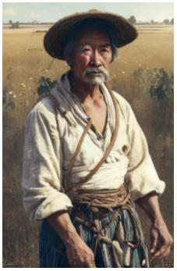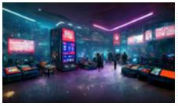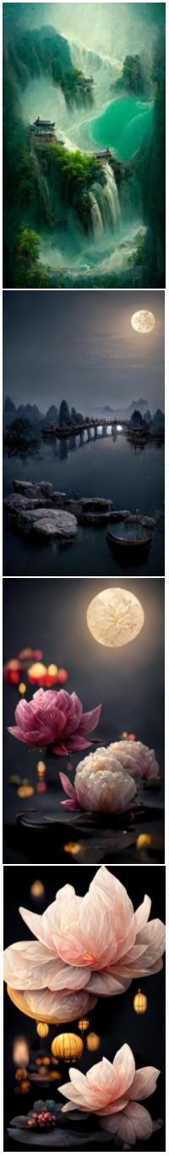

One kind of flower is pink. Its petals are as deep as sea water,
and its heart is like dew. There are many green leaves on the
branches, and there are many crystal white button chrysanthemums.
You can feel its loyalty and purity in comparison with loveHD, --
ar 9:16 --q 2
61
62
63
64
65
66
Surreal CG rendering in Ancient China Jiangnan Water Township
Architecture, Night View Meaning Environment Yellow willows, the
moon except the current water, And the stream is clear and real.
Real. 8K--hd --ar 9:16
Surreal CG rendering in ancient China, artistic conception of
night scene of ancient architecture in Wuzhen Snow . Moon, willow,
except current. water, And the stream is clear and real. Real. 8K-
-hd --ar 9:16
One soda float in a glass with clear blue soda and vanilla ice
cream on top, photorealistic, menu book, forward light, bright
lighting --w 512 --h 1024 --testp
focus post apocalypse floating city :: pastel color hazy clouds ::
cinematic :: galaxy bubbles :: render :: dreamy --ar 3:2
anime wallpaper、movie poster、featuring Hatsune Miku from
Vocaloid、she's in her early 20s、pin-up、nighttime concert、
character illustration in the style of Kimi no Na wa、your name、
Makoto Shinkai、Atelier Rorona、Granblue Fantasy、Atelier Lulua、
Last Exile、Atelier Firis、Guilty Crown、2k、Ghost in the Shell、
Hyper Dimension Neptunia --aspect 16:9
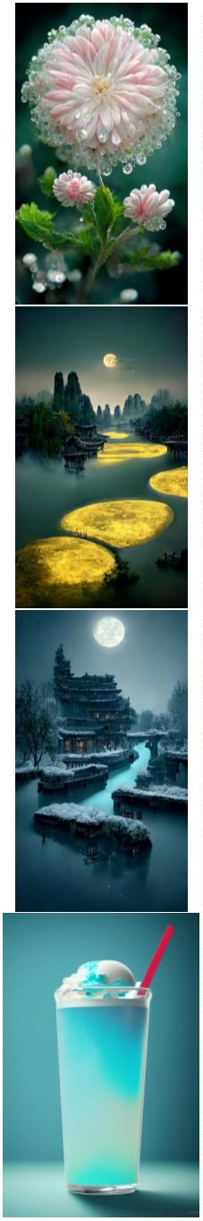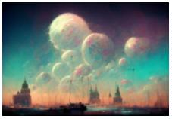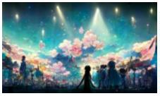

Heavenly wizardpunk city , night , trending on artstation ,
cinematic lighting , hyper detailed , insane details , intricate ,
elite , elegant , luxury , dramatic lighting , CGsociety ,
hypermaximalist , golden ratio , octane render , weta digital ,
micro details , ray trace 4k , --test --ar 16:9
67
68
69
70
71
72
sparkling pastel rainbow dye Maguk waterfall Kakadu , Animation
art , Breath of the wild , studio ghibli style , sun rays ,
fantasy feeling , lush vegetation and fern gorge , plants ,
miyazaki , Shinkai Makoto , hyper detail , octane render , --w
1024 --h 1792
focus post apocalypse floating city :: pastel color hazy clouds ::
cinematic :: galaxy bubbles :: render :: dreamy --ar 3:2
Environment aggressive courtyard chinese city :: people military，
robots people :: background future ruined chinese city ::
Mythology，cinematic，detailed atmospheric，epic，concept art，
very strange things，mid morning，blue dark skies，shafts of
lighting，mist， photorealistic，concept art，volumetric light，
cinematic epic + rule of thirds | 35mm | octane render，8k，corona
render，movie concept art，octane render，cinematic，trending on
artstation，movie concept art，cinematic composition，ultra
detailed，realistic， hiperealistic，volumetric lighting，--ar 3:1
beautiful,stunning,Azure Dragon,breathtaking,mirrors,glass,magic
circle,magic
portal,fantasy,mist,bioluminescence,crystals,gold,nebula,hypeet-
realistic,unreal engine --ar 9:16 --q 2 --s 15000 --chaos 5
beautiful,stunning, A splendid dragon，
breathtaking,mirrors,glass,magic circle,magic
portal,fantasy,mist,bioluminescence,crystals,gold,nebula,hypeet-
realistic,unreal engine --ar 9:16 --q 2 --s 15000 --chaos 5
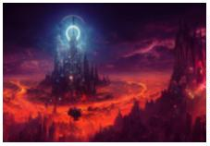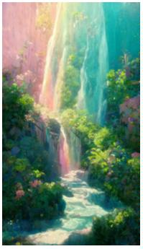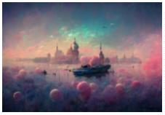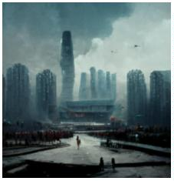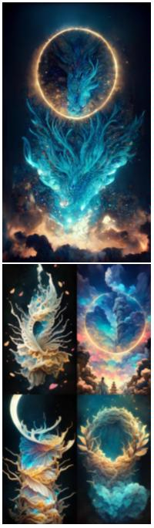

In the night sky, stars shine on silky beach, moon, elf light,
stars, stars shine, golden beach, starry sky, matte painting by
Michael James Smith, CG rendering, volume light, space art,
Bioluminescence, Unreal Engine 5, ultra wide Angle, high
definition --ar 9:16
73
74
75
76
77
78
The child's profile,carving, line art, gothic, multi-fantasy,
absolutely symmetrical,multi-detailed,absolutely clear --ar 9:16
The head of a sheep, the body of a lion, the wings of an
eagle,carving, line art, gothic, multi-fantasy, absolutely
symmetrical,multi-detailed,absolutely clear --ar 9:16
Guan Yu,carving, line art, gothic, multi-fantasy, absolutely
symmetrical,multi-detailed,absolutely clear --ar 9:16
Cat knight, portrait, finely detailed armor, intricate design,
silver, silk, cinematic lighting, 4k
datamosh, Graceful Midnight Angel of God + elegant details +
divine fantasy aesthetic + epic cinematic view + high details +
realism + octane render + volumetric soft light + post processing
+ denoise + 8k + ornate + elegant + Luminous color + Spiritual +
psychedelic --hd --no blur --ar 9:16 --q 2 --s 5000 --uplight
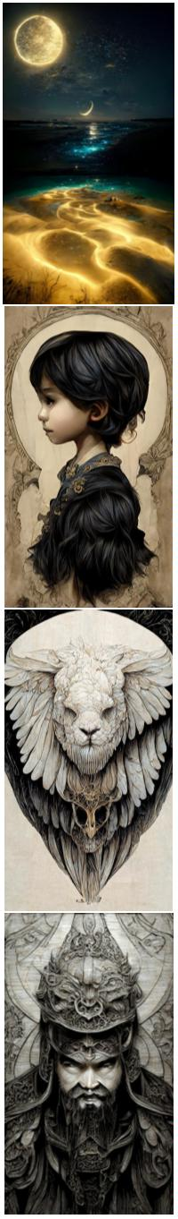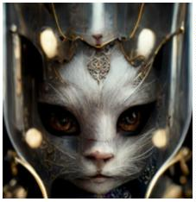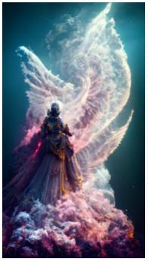

datamosh, Graceful Midnight Angel of God + elegant details +
divine fantasy aesthetic + epic cinematic view + high details +
realism + octane render + volumetric soft light + post processing
+ denoise + 8k + ornate + elegant + Luminous color + Spiritual +
psychedelic --hd --no blur --ar 9:16 --q 2 --s 5000 --uplight
79
80
81
82
83
84
datamosh, Graceful Midnight Angel of God + elegant details +
divine fantasy aesthetic + epic cinematic view + high details +
realism + octane render + volumetric soft light + post processing
+ denoise + 8k + ornate + elegant + Luminous color + Spiritual
Broken photo frames and butterfly specimen glass on the ground,
dappled light shining on the glass diamonds, --ar 16:9 --upbeta -
-q 2
One kind of flower is pink, its petals are transparent, deep as
sea water, crystal like dew, it can feel the loyalty and purity of
love, 8K ,HD --ar 16:9 --upbeta
closeup, mirrored portrait of Kristen McMenamy, covered in broken
mirrors in a low-poly style, detailed, soft background, cinematic,
hd photo, 4k, telephoto lens，--test --creative --ar 9:16
Surreal CG rendering of ancient China, a forest of peach blossoms
with an ancient Chinese pavilion in the woods, water pool, Chinese
fantasy novel scene +ultra wide Angle + detailed + beautiful
fanatasy art + matte painting by a senior matte painter +
cgsociety + masterpiece --ar 9:16 --test --creative
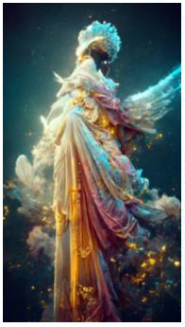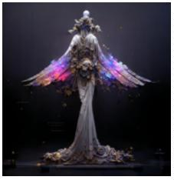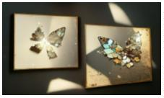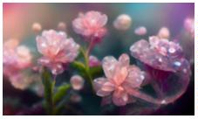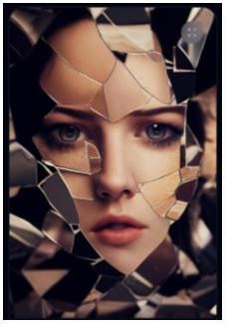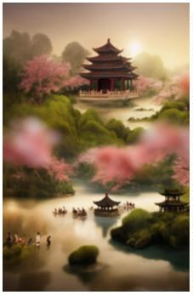

This is a real picture, a lavender garden under the moonlight,
many butterflies flying, studio lighting, octane rendering, film
level post-processing,8k,HD, --ar 9:16
85
86
87
88
89
90
beautiful ethereal cyberpunk girl, full face portrait, low angle,
intricate, highly detailed, digital painting, hyperrealistic,
artstation, concept art, smooth, sharp focus, illustration,
dystopian background, Unreal Engine 5, 8K，--test --creative --ar
9:16
young woman, pink hair, gorgeous, glowing teal eyes, elegant,
intricate, highly detailed, digital painting, artstation, concept
art, sharp focus, illustration, art by Ross tran --test --creative
--ar 9:16
automaton that look like porcelain doll wearing baroque and rococo
style outfit by charlie bowater, WLOP, artgerm and Jason Chan --
test --creative --ar 9:16
futuristic city deep in thick forest with monorail sci-fi ,
hyperdetailed technical precision, cinematic, ultrareal, octane
render, volumetric lighting, 8k ,--test --creative --ar 9:16
Character, Hybrid class, Rogue Wizard, Dungeons&Dragons Style,
Artstation, concept art, Artist Jesper Ejsing, sense of awe,
Octane render, Unreal 5 engine, Godrays, Forrest, daylight, low
mist,--test --creative --ar 9:16
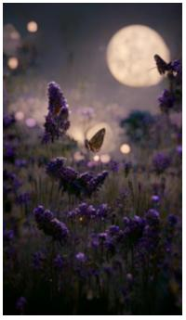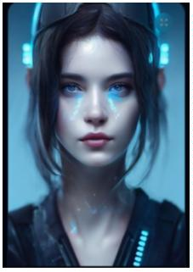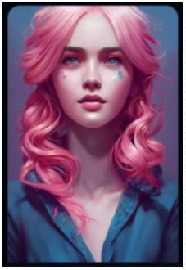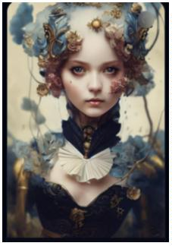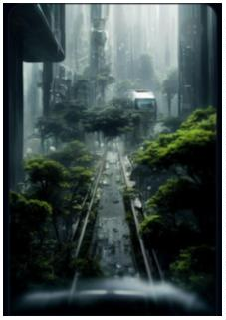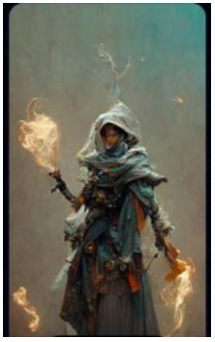

The Moon Knight dissolving into swirling sand, sandman, volumetric
dust, cinematic lighting, close up portrait，--test --creative --
ar 9:16
91
92
93
94
95
96
temperance tarot card featuring an angel, vaporwave color scheme,
ultra detailed, digital art, photo realistic, 4K, Cinematic，--
test --creative --ar 9:16
sunlit surrealist collapse of the galaxy in on itself
metaphorically, a person holding the universe, cinimatic, highly
illustrative rendering, highly detailed by rafał olbiński,
photoreal, Houdini Render，--test --creative --ar 9:16
open interior of a great hall, chrome, violet, sci-fi,
technological, otherworldly, stars in the sky at night, beautiful,
industrial, futuristic, dark fantasy, atmospheric, photorealistic,
highly detailed，--test --creative --ar 9:16
a beautiful fashion doll dressed as a demon, hyper realistic,
photo realistic, extreme detail, cinematic lighting realistic
facial features，--test --creative --ar 9:16
Breathtaking baroque Madelaine Petsch beauty, full head, Oval
baroque frame, acanthus scroll, Painted by artgerm, Alphonse
Mucha, Akihiko yoshida, sakimichan, krenz cushart, low angle shot,
digital painting，--test --creative --ar 9:16
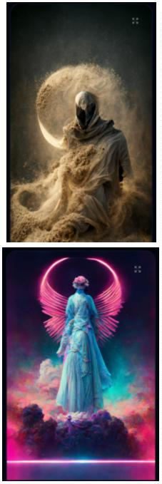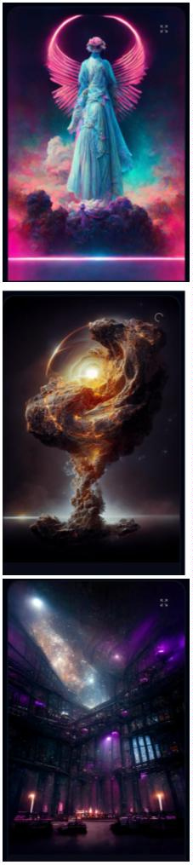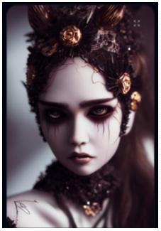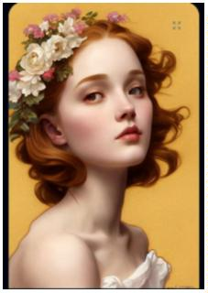

A high-definition CG rendering of a dark rose forest, a rose path,
long floating red roses on the ground, fireflies, luminous ovules,
light effects, snowstorm style art trendsmagical light fognight
timelow light volumetric lightingue4 zbrushmarmostt toolbag HD --
ar 9:16
97
A ultra-realistic CG rendering of Ancient China,Old houses, green
trees, shade, clouds, Trending on artstation --ar 9:16 --test --
upbeta
98
It is a beautiful picture. There are many huge blue roses floating
in the deep sea, the brightness of the moon, magic clouds, several
sailboats, giant sailboats, Klein Blue Dream rendering, surreal,
surreal, super beautiful dream, HD,beautiful ethereal fairyland--
HD --ar 9:16
99
A ultra-realistic CG rendering of Ancient China,Old houses, green
trees, shade, clouds, Trending on artstation --ar 9:16
100
