Bunny, Twitter icon [pixiv Art] [Watercolor] [Whole Body] [Ultra Detailed Flowers and Feathers] [Epic, Matte, High Detail, Great Wisdom, Empty, Silent, Cosmic, Spiritual, Oriental Fantasy, Multiverse, Baroque, Victorian, Epic Composition, Decoration] [Crystal, Clarity, Noise Reduction, High Detail, Beautiful Lighting, Cinema-like lighting [Final Fantasy, League of Heroes, Shiro] [Art Station Trends, Anime] [Krenz Kushte, Huang Kwang-jian, Hokusai Katsushika, Alfonse Muzha Art]8k --v 4 --v 3 | 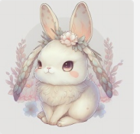
Chinese Dragon Baby, Twitter icon [pixiv Art] [Watercolor] [Whole Body] [Ultra-detailed Flowers and feathers] [Epic, Matte, Highly Detailed, Great Wisdom, Empty, Silent, Cosmic, Spiritual, Oriental Fantasy, Multiverse, Baroque, Victorian, Epic Composition, Decoration] [Crystal, Clarity, Noise Reduction, Highly Detailed, Beautiful Lighting, Cinema-like lighting [Final Fantasy, League of Heroes, Shiro] [Art Station Trends, Anime] [Krenz Kushte, Huang Kwang-jian, Hokusai Katsushika, Alfonse Muzha Art]8k --v 4 --v 3 | 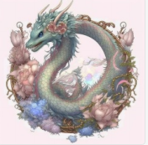
Baby Snake, Twitter icon [pixiv Art] [Watercolor] [Whole Body] [Ultra Detailed Flowers and Feathers] [Epic, Matte, High Detail, Great Wisdom, Empty, Silent, Cosmic, Spiritual, Oriental Fantasy, Multiverse, Baroque, Victorian, Epic Composition, Decoration] [Crystal, Clarity, Noise Reduction, High Detail, Beautiful Lighting, Cinema-like lighting [Final Fantasy, League of Heroes, Shiro] [Art Station Trends, Anime] [Krenz Kushte, Huang Kwang-jian, Hokusai Katsushika, Alfonse Muzha Art]8k --v 4 --v 3 | 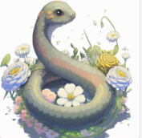
Baby Horse, Twitter icon [pixiv Art] [Watercolor] [Full Body] [Ultra Detailed Flowers and Feathers] [Epic, Matte, High Detail, Great Wisdom, Empty, Silent, Cosmic, Spiritual, Oriental Fantasy, Multiverse, Baroque, Victorian, Epic Composition, Decoration] [Crystal, Clarity, Noise Reduction, High Detail, Beautiful Lighting, Cinema-like lighting [Final Fantasy, League of Heroes, Shiro] [Art Station Trends, Anime] [Krenz Kushte, Huang Kwang-jian, Hokusai Katsushika, Alfonse Muzha Art]8k --v 4 --v 3 | 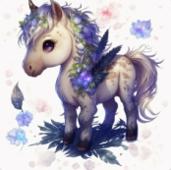
Sheep Baby, Twitter icon [pixiv Art] [Watercolor] [Whole Body] [Ultra Detailed Flowers and Feathers] [Epic, Matte, High Detail, Great Wisdom, Empty, Silent, Cosmic, Spiritual, Oriental Fantasy, Multiverse, Baroque, Victorian, Epic Composition, Decoration] [Crystal, Clarity, Noise Reduction, High Detail, Beautiful Lighting, Cinema-like lighting [Final Fantasy, League of Heroes, Shiro] [Art Station Trends, Anime] [Krenz Kushte, Huang Kwang-jian, Hokusai Katsushika, Alfonse Muzha Art]8k --v 4 --v 3 | 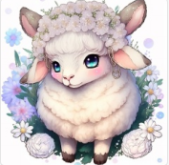
Baby Dog, Twitter icon [pixiv Art] [Watercolor] [Whole Body] [Ultra Detailed Flowers and Feathers] [Epic, Matte, High Detail, Great Wisdom, Empty, Silent, Cosmic, Spiritual, Oriental Fantasy, Multiverse, Baroque, Victorian, Epic Composition, Decoration] [Crystal, Clarity, Noise Reduction, High Detail, Beautiful Lighting, Cinema-like lighting [Final Fantasy, League of Heroes, Shiro] [Art Station Trends, Anime] [Krenz Kushte, Huang Kwang-jian, Hokusai Katsushika, Alfonse Muzha Art]8k --v 4 --v 3 | 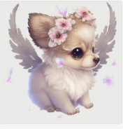
Baby Pig, Twitter icon [pixiv Art] [Watercolor] [Whole Body] [Ultra Detailed Flowers and Feathers] [Epic, Matte, High Detail, Great Wisdom, Empty, Silent, Cosmic, Spiritual, Oriental Fantasy, Multiverse, Baroque, Victorian, Epic Composition, Decoration] [Crystal, Clarity, Noise Reduction, High Detail, Beautiful Lighting, Cinema-like lighting [Final Fantasy, League of Heroes, Shiro] [Art Station Trends, Anime] [Krenz Kushte, Huang Kwang-jian, Hokusai Katsushika, Alfonse Muzha Art]8k --v 4 --v 3 | 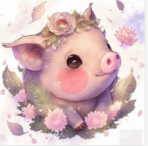
Detailed sculptures of fire rats grow from molten glass, Lots of detail, workshop background, backlighting, studio lighting, Photography, flame, octane lander, 8k --v 4 --q 2 --v 4 --upbeta | 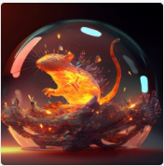
Exquisitely detailed sculptures of fire bulls grow from molten glass, Lots of detail, workshop background, backlighting, studio lighting, Photography, flame, octane lander, 8k --v 4 --q 2 --v 4 --upbeta | 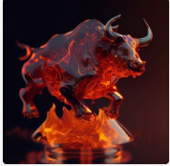
Detailed sculptures of fire rabbits grow from molten glass, Lots of detail, workshop background, backlighting, studio lighting, Photography, flame, octane lander, 8k --v 4 --q 2 --v 4 --upbeta | 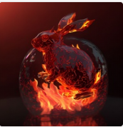
A detailed sculpture of a fire horse grows out of molten glass, Lots of detail, workshop background, backlighting, studio lighting, Photography, flame, octane lander, 8k --v 4 --q 2 --v 4 --upbeta | 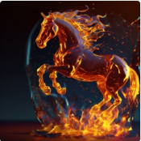
A detailed sculpture of a fire rooster grows out of molten glass, Lots of detail, workshop background, backlighting, studio lighting, Photography, flame, octane lander, 8k --v 4 --q 2 --v 4 --upbeta | 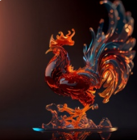
A detailed sculpture of a fire monkey grows out of molten glass, Lots of detail, workshop background, backlighting, studio lighting, Photography, flame, octane lander, 8k --v 4 --q 2 --v 4 --upbeta | 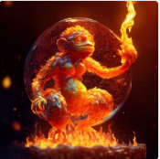
Cute puppy, Sleeping on a pillow, Twitter icon [pixiv Art] [Watercolor] [Full Body] [Ultra Detailed Bed and Pillow] [Epic, Matte, High Detail, Great Wisdom, Empty, Silent, Cosmic, Spiritual, Oriental Fantasy, Multiverse, Baroque, Victorian, Epic Composition, Decoration] [Crystal, Clarity, Noise Reduction, High Detail, Beautiful Lighting, Cinema-like lighting [Final Fantasy, League of Heroes, Shiro] [Trend of Art Station, Anime] [Krenz Kushte, Huang Guangjian, Hokusai Katsushika, Alfonse Mocha Art] 8k --v 4 --v 3 | 
Cute horse, Sleeping on a pillow, Twitter icon [pixiv Art] [Watercolor] [Full Body] [Ultra Detailed Bed and Pillow] [Epic, Matte, High Detail, Great Wisdom, Empty, Silent, Cosmic, Spiritual, Oriental Fantasy, Multiverse, Baroque, Victorian, Epic Composition, Decoration] [Crystal, Clarity, Noise Reduction, High Detail, Beautiful Lighting, Cinema-like lighting [Final Fantasy, League of Heroes, Shiro] [Trend of Art Station, Anime] [Krenz Kushte, Huang Guangjian, Hokusai Katsushika, Alfonse Mocha Art] 8k --v 4 --v 3 | 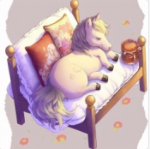
Cute pig, Sleeping on a pillow, Twitter icon [pixiv Art] [Watercolor] [Full Body] [Ultra Detailed Bed and Pillow] [Epic, Matte, High Detail, Great Wisdom, Empty, Silent, Cosmic, Spiritual, Oriental Fantasy, Multiverse, Baroque, Victorian, Epic Composition, Decoration] [Crystal, Clarity, Noise Reduction, High Detail, Beautiful Lighting, Cinema-like lighting [Final Fantasy, League of Heroes, Shiro] [Trend of Art Station, Anime] [Krenz Kushte, Huang Guangjian, Hokusai Katsushika, Alfonse Mocha Art] 8k --v 4 --v 3 | 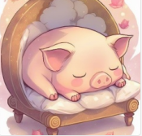
Cute sheep, Sleeping on a pillow, Twitter icon [pixiv Art] [Watercolor] [Full Body] [Ultra Detailed Bed and Pillow] [Epic, Matte, High Detail, Great Wisdom, Empty, Silent, Cosmic, Spiritual, Oriental Fantasy, Multiverse, Baroque, Victorian, Epic Composition, Decoration] [Crystal, Clarity, Noise Reduction, High Detail, Beautiful Lighting, Cinema-like lighting [Final Fantasy, League of Heroes, Shiro] [Trend of Art Station, Anime] [Krenz Kushte, Huang Guangjian, Hokusai Katsushika, Alfonse Mocha Art] 8k --v 4 --v 3 | 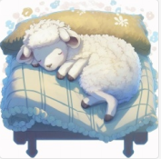
Cute rabbit, Sleeping on a pillow, Twitter icon [pixiv Art] [Watercolor] [Full Body] [Ultra Detailed Bed and Pillow] [Epic, Matte, High Detail, Great Wisdom, Empty, Silent, Cosmic, Spiritual, Oriental Fantasy, Multiverse, Baroque, Victorian, Epic Composition, Decoration] [Crystal, Clarity, Noise Reduction, High Detail, Beautiful Lighting, Cinema-like lighting [Final Fantasy, League of Heroes, Shiro] [Trend of Art Station, Anime] [Krenz Kushte, Huang Guangjian, Hokusai Katsushika, Alfonse Mocha Art] 8k --v 4 --v 3 | 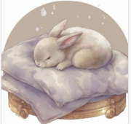
Cute chicken, Sleeping on a pillow, Twitter icon [pixiv Art] [Watercolor] [Full Body] [Ultra Detailed Bed and Pillow] [Epic, Matte, High Detail, Great Wisdom, Empty, Silent, Cosmic, Spiritual, Oriental Fantasy, Multiverse, Baroque, Victorian, Epic Composition, Decoration] [Crystal, Clarity, Noise Reduction, High Detail, Beautiful Lighting, Cinema-like lighting [Final Fantasy, League of Heroes, Shiro] [Trend of Art Station, Anime] [Krenz Kushte, Huang Guangjian, Hokusai Katsushika, Alfonse Mocha Art] 8k --v 4 --v 3 | 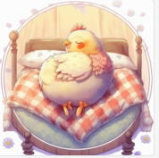
Cute monkey, Sleeping on a pillow, Twitter icon [pixiv Art] [Watercolor] [Full Body] [Ultra Detailed Bed and Pillow] [Epic, Matte, High Detail, Great Wisdom, Empty, Silent, Cosmic, Spiritual, Oriental Fantasy, Multiverse, Baroque, Victorian, Epic Composition, Decoration] [Crystal, Clarity, Noise Reduction, High Detail, Beautiful Lighting, Cinema-like lighting [Final Fantasy, League of Heroes, Shiro] [Trend of Art Station, Anime] [Krenz Kushte, Huang Guangjian, Hokusai Katsushika, Alfonse Mocha Art] 8k --v 4 --v 3 | 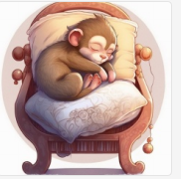
Cute Chinese dragon, Sleeping on a pillow, Twitter icon [pixiv Art] [Watercolor] [Full Body] [Ultra Detailed Bed and Pillow] [Epic, Matte, High Detail, Great Wisdom, Empty, Silent, Cosmic, Spiritual, Oriental Fantasy, Multiverse, Baroque, Victorian, Epic Composition, Decoration] [Crystal, Clarity, Noise Reduction, High Detail, Beautiful Lighting, Cinema-like lighting [Final Fantasy, League of Heroes, Shiro] [Trend of Art Station, Anime] [Krenz Kushte, Huang Guangjian, Hokusai Katsushika, Alfonse Mocha Art] 8k --v 4 --v 3 | 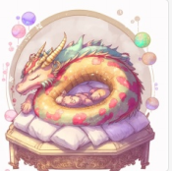
Cute snake, Sleeping on a pillow, Twitter icon [pixiv Art] [Watercolor] [Full Body] [Ultra Detailed Bed and Pillow] [Epic, Matte, High Detail, Great Wisdom, Empty, Silent, Cosmic, Spiritual, Oriental Fantasy, Multiverse, Baroque, Victorian, Epic Composition, Decoration] [Crystal, Clarity, Noise Reduction, High Detail, Beautiful Lighting, Cinema-like lighting [Final Fantasy, League of Heroes, Shiro] [Trend of Art Station, Anime] [Krenz Kushte, Huang Guangjian, Hokusai Katsushika, Alfonse Mocha Art] 8k --v 4 --v 3 | 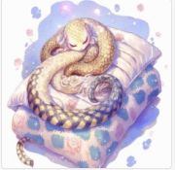
Cute sheep, Sleeping on a pillow, Twitter icon [pixiv Art] [Watercolor] [Full Body] [Ultra Detailed Bed and Pillow] [Epic, Matte, High Detail, Great Wisdom, Empty, Silent, Cosmic, Spiritual, Oriental Fantasy, Multiverse, Baroque, Victorian, Epic Composition, Decoration] [Crystal, Clarity, Noise Reduction, High Detail, Beautiful Lighting, Cinema-like lighting [Final Fantasy, League of Heroes, Shiro] [Trend of Art Station, Anime] [Krenz Kushte, Huang Guangjian, Hokusai Katsushika, Alfonse Mocha Art] 8k --v 4 --v 3 | 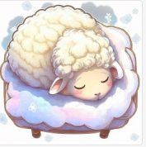
Cute baby tiger, Sleeping on a pillow, Twitter icon [pixiv Art] [Watercolor] [Full Body] [Ultra Detailed Bed and Pillow] [Epic, Matte, High Detail, Great Wisdom, Empty, Silent, Cosmic, Spiritual, Oriental Fantasy, Multiverse, Baroque, Victorian, Epic Composition, Decoration] [Crystal, Clarity, Noise Reduction, High Detail, Beautiful Lighting, Cinema-like lighting [Final Fantasy, League of Heroes, Shiro] [Trend of Art Station, Anime] [Krenz Kushte, Huang Guangjian, Hokusai Katsushika, Alfonse Mocha Art] 8k --v 4 --v 3 | 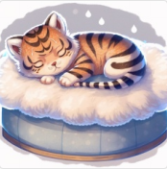
Pixar style cartoon cute mechanical ceramic horse with beautiful traditional pattern, Chinese white ceramic shiny, metallic white, gold, glass, oil water swirl splash, spin, glitter with detailed armor, diffuse lighting, fantasy, intricate, elegant , highly detailed, lifelike, photorealistic, digital painting, art station, illustration, concept art, smooth, sharp focus, photography, surreal, octane rendering --v 4 --q 2 --uplight | 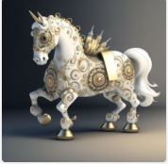
Pixar style cartoon cute mechanical ceramic monkey with beautiful traditional pattern, Chinese white ceramic shiny, metallic white, gold, glass, oil water swirl splash, spin, glitter with detailed armor, diffuse lighting, fantasy, intricate, elegant , highly detailed, lifelike, photorealistic, digital painting, art station, illustration, concept art, smooth, sharp focus, photography, surreal, octane rendering --v 4 --q 2 --uplight | 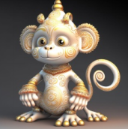
Pixar style cartoon cute mechanical ceramic dragon with beautiful traditional pattern, Chinese white ceramic shiny, metallic white, gold, glass, oil water swirl splash, spin, glitter with detailed armor, diffuse lighting, fantasy, intricate, elegant , highly detailed, lifelike, photorealistic, digital painting, art station, illustration, concept art, smooth, sharp focus, photography, surreal, octane rendering --v 4 --q 2 --uplight | 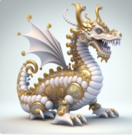
Pixar style cartoon cute mechanical ceramic mouse with beautiful traditional pattern, Chinese white ceramic shiny, metallic white, gold, glass, oil water swirl splash, spin, glitter with detailed armor, diffuse lighting, fantasy, intricate, elegant , highly detailed, lifelike, photorealistic, digital painting, art station, illustration, concept art, smooth, sharp focus, photography, surreal, octane rendering --v 4 --q 2 --uplight | 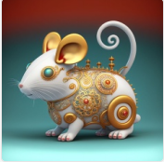
Pixar style cartoon cute mechanical ceramic cow with beautiful traditional pattern, Chinese white ceramic shiny, metallic white, gold, glass, oil water swirl splash, spin, glitter with detailed armor, diffuse lighting, fantasy, intricate, elegant , highly detailed, lifelike, photorealistic, digital painting, art station, illustration, concept art, smooth, sharp focus, photography, surreal, octane rendering --v 4 --q 2 --uplight | 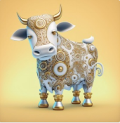
Pixar style cartoon cute mechanical ceramic rooster with beautiful traditional pattern, Chinese white ceramic shiny, metallic white, gold, glass, oil water swirl splash, spin, glitter with detailed armor, diffuse lighting, fantasy, intricate, elegant , highly detailed, lifelike, photorealistic, digital painting, art station, illustration, concept art, smooth, sharp focus, photography, surreal, octane rendering --v 4 --q 2 --uplight | 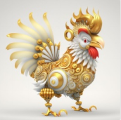
Pixar style cartoon cute mechanical ceramic dog with beautiful traditional pattern, Chinese white ceramic shiny, metallic white, gold, glass, oil water swirl splash, spin, glitter with detailed armor, diffuse lighting, fantasy, intricate, elegant , highly detailed, lifelike, photorealistic, digital painting, art station, illustration, concept art, smooth, sharp focus, photography, surreal, octane rendering --v 4 --q 2 --uplight | 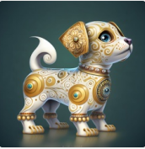
the magnificent chinese ice snake , its crystal feathers like snow, dances in the air like snow flakes in china charming snake tail, super fine fur, turquoise red eyes, portrait, turquoise base, jewelry, complex details, film lighting, blue design, illusory engine, octane rendering, snake crazy consul peter morbach, jordan chinese mythology,animals , snake atmospheric aperture, magic aperture, dream aperture, flame aperture, snake signs the rainbow bridge to heaven, light and dark, the corner of hell, hd aesthetic pictures, hd, 4k hd, uhd, 3d rendering, virtual engine, very detailed --v 4 --upbeta | 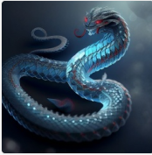
the magnificent chinese ice tiger, Full body of a tiger, its crystal feathers like snow, dances in the air like snowflakes in china charming tiger tail, super fine fur, turquoise red eyes, portrait, turquoise base, jewelry, complex details, film lighting, blue design, illusory engine, octane rendering, mouse crazy consul peter morbach, jordan chinese mythology,animals , tiger atmospheric aperture, magic aperture, dream aperture, flame aperture, tiger signs the rainbow bridge to heaven, light and dark, the corner of hell, hd aesthetic pictures, hd, 4k hd, uhd, 3d rendering, virtual engine, very detailed --v 4 --upbeta | 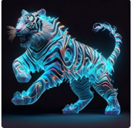
the magnificent chinese ice sheep , its crystal feathers like snow, dances in the air like snowflakes in china charming sheep tail, super fine fur, turquoise red eyes, portrait, turquoise base, jewelry, complex details, film lighting, blue design, illusory engine, octane rendering, sheep crazy consul peter morbach, jordan chinese mythology,animals , sheep atmospheric aperture, magic aperture, dream aperture, flame aperture, sheep signs the rainbow bridge to heaven, light and dark, the corner of hell, hd aesthetic pictures, hd, 4k hd, uhd, 3d rendering, virtual engine, very detailed --v 4 --upbeta | 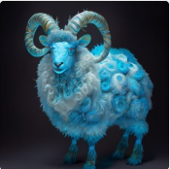
the magnificent chinese ice mouse , its crystal feathers like snow, dances in the air like snowflakes in china charming mouse tail, super fine fur, turquoise red eyes, portrait, turquoise base, jewelry, complex details, film lighting, blue design, illusory engine, octane rendering, mouse crazy consul peter morbach, jordan grimmer, chinese mythology,animals , mouse atmospheric aperture, magic aperture, dream aperture, flame aperture, mouse signs the rainbow bridge to heaven, light and dark, the corner of hell, hd aesthetic pictures, hd, 4k hd, uhd, 3d rendering, virtual engine, very detailed --v 4 --upbeta | 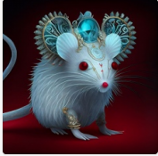
Chinese Dragon, Twitter icon [pixiv Art] [Watercolor] [Whole body] [Ultra-detailed Red Hanfu,Fireworks, Chinese New Year Elements] [Epic, Matte, Highly Detailed, Great Wisdom, Empty, Silent, Cosmic, Spiritual, Oriental Fantasy, Multiverse, Baroque, Victorian, Epic Composition, Decoration] [Crystal, Clear, Noise Reduction, Highly Detailed, Beautiful lighting, cinema-like lighting [Final Fantasy, League of Legends, Shiro] [Art Station Trends, Anime] [Krenz Kushte, Huang Guangjian, Hokusai Katsushika, Alfonse Muzha Art]8k --v 4 | 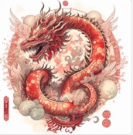
Snake, Twitter icon [pixiv Art] [Watercolor] [Whole body] [Ultra-detailed Red Hanfu,Fireworks, Chinese New Year Elements] [Epic, Matte, Highly Detailed, Great Wisdom, Empty, Silent, Cosmic, Spiritual, Oriental Fantasy, Multiverse, Baroque, Victorian, Epic Composition, Decoration] [Crystal, Clear, Noise Reduction, Highly Detailed, Beautiful lighting, cinema-like lighting [Final Fantasy, League of Legends, Shiro] [Art Station Trends, Anime] [Krenz Kushte, Huang Guangjian, Hokusai Katsushika, Alfonse Muzha Art]8k --v 4 | 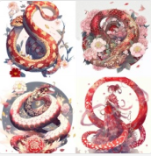
Baby Mouse, Twitter icon [pixiv Art] [Watercolor] [Whole body] [Ultra-detailed Red Hanfu,Fireworks, Chinese New Year Elements] [Epic, Matte, Highly Detailed, Great Wisdom, Empty, Silent, Cosmic, Spiritual, Oriental Fantasy, Multiverse, Baroque, Victorian, Epic Composition, Decoration] [Crystal, Clear, Noise Reduction, Highly Detailed, Beautiful lighting, cinema-like lighting [Final Fantasy, League of Legends, Shiro] [Art Station Trends, Anime] [Krenz Kushte, Huang Guangjian, Hokusai Katsushika, Alfonse Muzha Art]8k --v 4 | 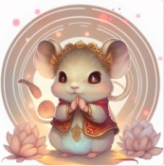
Baby dog, Twitter icon [pixiv Art] [Watercolor] [Whole body] [Ultra-detailed Red Hanfu,Fireworks, Chinese New Year Elements] [Epic, Matte, Highly Detailed, Great Wisdom, Empty, Silent, Cosmic, Spiritual, Oriental Fantasy, Multiverse, Baroque, Victorian, Epic Composition, Decoration] [Crystal, Clear, Noise Reduction, Highly Detailed, Beautiful lighting, cinema-like lighting [Final Fantasy, League of Legends, Shiro] [Art Station Trends, Anime] [Krenz Kushte, Huang Guangjian, Hokusai Katsushika, Alfonse Muzha Art]8k --v 4 | 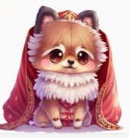
baby sheep, Twitter icon [pixiv Art] [Watercolor] [Whole body] [Super detailed Red Hanfu, fireworks, Red Ribbon, Chinese New Year Atmosphere, Window cut elements] [Epic, Matte, High Detail, Great Wisdom, Empty, Silence, Universe, Spirit, Oriental Fantasy, Multiverse, Baroque, Victorian, Epic Composition, decoration] [Crystal, Clear, Noise reduction, high detail, beautiful lighting, cinema-like lighting [Final Fantasy, League of Legends, Shiro] [Art Station Trends, Anime] [Krenz Kushte, Huang Guangjian, Hokusai Katsushika, Alfonse Muzha Art]8k --v 4 | 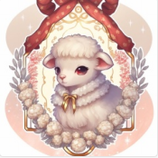
baby horse,Twitter icon [pixiv Art] [Watercolor] [Whole body] [Super detailed Red Hanfu, fireworks, Red Ribbon, Chinese New Year Atmosphere, Window cut elements] [Epic, Matte, High Detail, Great Wisdom, Empty, Silence, Universe, Spirit, Oriental Fantasy, Multiverse, Baroque, Victorian, Epic Composition, decoration] [Crystal, Clear, Noise reduction, high detail, beautiful lighting, cinema-like lighting [Final Fantasy, League of Legends, Shiro] [Art Station Trends, Anime] [Krenz Kushte, Huang Guangjian, Hokusai Katsushika, Alfonse Muzha Art]8k --v 4 | 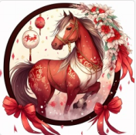
Anthropomorphic baby cow, Twitter icon [pixiv Art] [Watercolor] [Whole body] [Super detailed Red Hanfu, fireworks, Red Ribbon, Chinese New Year Atmosphere, Window cut elements] [Epic, Matte, High Detail, Great Wisdom, Empty, Silence, Universe, Spirit, Oriental Fantasy, Multiverse, Baroque, Victorian, Epic Composition, decoration] [Crystal, Clear, Noise reduction, high detail, beautiful lighting, cinema-like lighting [Final Fantasy, League of Legends, Shiro] [Art Station Trends, Anime] [Krenz Kushte, Huang Guangjian, Hokusai Katsushika, Alfonse Muzha Art]8k --v 4 | 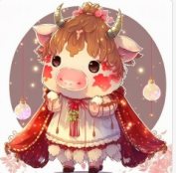
A Yoshimasa Tsuchiya smoke sculpture of a delicate rooster, filigree, aurora, celestial, delicate, dreamy, ethereal, art photography, moonlight hour --q 2 --v 4 | 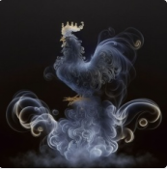
A Yoshimasa Tsuchiya smoke sculpture of a delicate snake, filigree, aurora, celestial, delicate, dreamy, ethereal, art photography, moonlight hour --q 2 --v 4 | 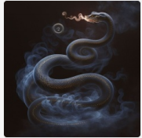
A Yoshimasa Tsuchiya smoke sculpture of a delicate sheep, filigree, aurora, celestial, delicate, dreamy, ethereal, art photography, moonlight hour --q 2 --v 4 | 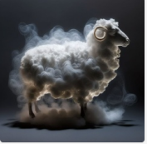
A Yoshimasa Tsuchiya smoke sculpture of a delicate ox, filigree, aurora, celestial, delicate, dreamy, ethereal, art photography, moonlight hour --q 2 --v 4 | 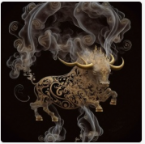
A Yoshimasa Tsuchiya smoke sculpture of a delicate dog, filigree, aurora, celestial, delicate, dreamy, ethereal, art photography, moonlight hour --q 2 --v 4 | 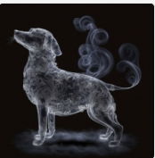
A Yoshimasa Tsuchiya smoke sculpture of a delicate bunny, filigree, aurora, celestial, delicate, dreamy, ethereal, art photography, moonlight hour --q 2 --v 4 | 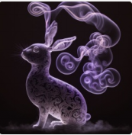
A Yoshimasa Tsuchiya smoke sculpture of a delicate Chinese dragon, filigree, aurora, celestial, delicate, dreamy, ethereal, art photography, moonlight hour --q 2 --v 4 | 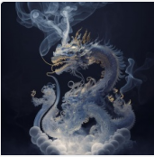
A Yoshimasa Tsuchiya smoke sculpture of a delicate tiger, filigree, aurora, celestial, delicate, dreamy, ethereal, art photography, moonlight hour --q 2 --v 4 | 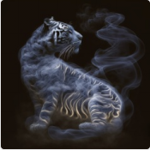
A Yoshimasa Tsuchiya smoke sculpture of a delicate pegasus, filigree, aurora, celestial, delicate, dreamy, ethereal, art photography, moonlight hour --q 2 --v 4 | 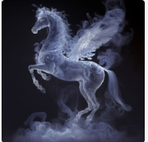
paper quilling, paper cut art,paper illustration baby monkey, twitter icon [pixiv art] [watercolor] [full body][hyper detailed flowers and feathers] [epic, Matte , highly detailed, great wisdom, empty, silent, universe, spirit, oriental fantasy, multiverse, Baroque, victorian, epic composition, ornaments] [crystal, clear, denoise, highly detailed, beautiful lighting, cinematic lighting] [final fantasy, league of legends, sekiro] [Trending on artstation, anime] [art by Krenz Cushart, Huang Guangjian, Hokusai, alphonse mucha] --v 4 | 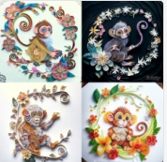
paper quilling, paper cut art,paper illustration baby dog, twitter icon [pixiv art] [watercolor] [full body][hyper detailed flowers and feathers] [epic, Matte , highly detailed, great wisdom, empty, silent, universe, spirit, oriental fantasy, multiverse, Baroque, victorian, epic composition, ornaments] [crystal, clear, denoise, highly detailed, beautiful lighting, cinematic lighting] [final fantasy, league of legends, sekiro] [Trending on artstation, anime] [art by Krenz Cushart, Huang Guangjian, Hokusai, alphonse mucha] --v 4 | 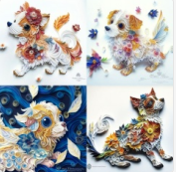
paper quilling, paper cut art,paper illustration baby Chinese dragon,twitter icon [pixiv art] [watercolor] [full body][hyper detailed flowers and feathers] [epic, Matte , highly detailed, great wisdom, empty, silent, universe, spirit, oriental fantasy, multiverse, Baroque, victorian, epic composition, ornaments] [crystal, clear, denoise, highly detailed, beautiful lighting, cinematic lighting] [final fantasy, league of legends, sekiro] [Trending on artstation, anime] [art by Krenz Cushart, Huang Guangjian, Hokusai, alphonse mucha] --v 4 | 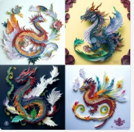
paper quilling, paper cut art,paper illustration baby sheep, twitter icon [pixiv art] [watercolor] [full body][hyper detailed flowers and feathers] [epic, Matte , highly detailed, great wisdom, empty, silent, universe, spirit, oriental fantasy, multiverse, Baroque, victorian, epic composition, ornaments] [crystal, clear, denoise, highly detailed, beautiful lighting, cinematic lighting] [final fantasy, league of legends, sekiro] [Trending on artstation, anime] [art by Krenz Cushart, Huang Guangjian, Hokusai, alphonse mucha] --v 4 | 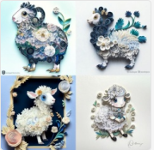
paper quilling, paper cut art,paper illustration baby mouse, twitter icon [pixiv art] [watercolor] [full body][hyper detailed flowers and feathers] [epic, Matte , highly detailed, great wisdom, empty, silent, universe, spirit, oriental fantasy, multiverse, Baroque, victorian, epic composition, ornaments] [crystal, clear, denoise, highly detailed, beautiful lighting, cinematic lighting] [final fantasy, league of legends, sekiro] [Trending on artstation, anime] [art by Krenz Cushart, Huang Guangjian, Hokusai, alphonse mucha] --v 4 | 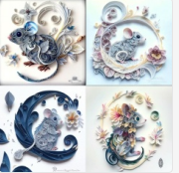
Multiple dimensions paper cut craft, paper illustration Tiny cute adorable anthropomorphic zodiac dog in Chinese Red Ethnic Style Hanfu, intricate furry details, soft cinematic lighting, 8k, portrait,pokemon anime style,octane render,rendered in Unreal Engine,hyperquality --v 4 | 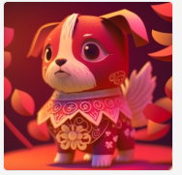
Multiple dimensions paper cut craft, paper illustration Tiny cute adorable anthropomorphic zodiac baby sheep in Chinese Red Ethnic Style Hanfu, intricate furry details, soft cinematic lighting, 8k, portrait,pokemon anime style,octane render,rendered in Unreal Engine,hyperquality --v 4 | 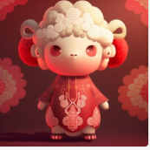
Multiple dimensions paper cut craft, paper illustration Tiny cute adorable zodiac baby pig in Chinese Red Ethnic Style Hanfu, intricate furry details, soft cinematic lighting, 8k, portrait,octane render,rendered in Unreal Engine,hyperquality --v 4 | 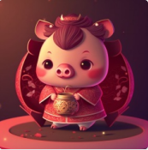
Multiple dimensions paper cut craft, paper illustration Tiny cute adorable zodiac baby monkey in Chinese Red Ethnic Style Hanfu, intricate furry details, soft cinematic lighting, 8k, portrait,octane render,rendered in Unreal Engine,hyperquality --v 4 | 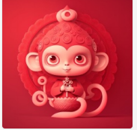
Multiple dimensions paper cut craft, paper illustration Tiny cute adorable zodiac snake in Chinese Red Ethnic Style Hanfu, intricate furry details, soft cinematic lighting, 8k, portrait,octane render,rendered in Unreal Engine,hyperquality --v 4 | 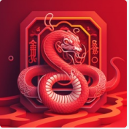
Multiple dimensions paper cut craft, paper illustration Tiny cute adorable zodiac baby cattle in Chinese Red Ethnic Style Hanfu, intricate furry details, soft cinematic lighting, 8k, portrait,octane render,rendered in Unreal Engine,hyperquality --v 4 | 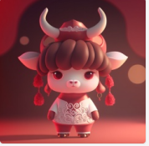
Multiple dimensions paper cut craft, paper illustration Tiny cute adorable zodiac baby horse in Chinese Red Ethnic Style Hanfu, intricate furry details, soft cinematic lighting, 8k, portrait,octane render,rendered in Unreal Engine,hyperquality --v 4 | 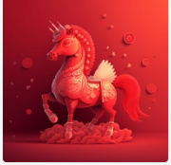
Multiple dimensions paper cut craft, paper illustration Tiny cute adorable anthropomorphic zodiac baby rabbit in Chinese Red Ethnic Style Hanfu, intricate furry details, soft cinematic lighting, 8k, portrait,pokemon anime style,octane render,rendered in Unreal Engine,hyperquality --v 4 | 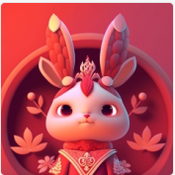
Multiple dimensions paper cut craft, paper illustration Tiny cute adorable anthropomorphic zodiac baby mouse in Chinese Red Ethnic Style Hanfu, intricate furry details, soft cinematic lighting, 8k, portrait,pokemon anime style,octane render,rendered in Unreal Engine,hyperquality --v 4 | 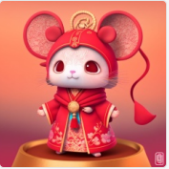
paper cut craft, paper illustration, chinese new year, mouse, colorful, very detailed, 8k --q 2 --upbeta --v 4 | 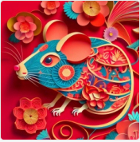
paper cut craft, paper illustration, chinese new year, rooster, colorful, very detailed, 8k --q 2 --upbeta --v 4 | 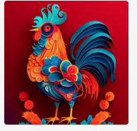
paper cut craft, paper illustration, chinese new year, sheep, colorful, very detailed, 8k --q 2 --upbeta --v 4 | 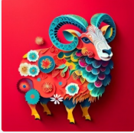
paper cut craft, paper illustration, chinese new year, dragon, colorful, very detailed, 8k --q 2 --upbeta --v 4 | 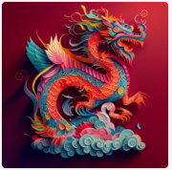
paper cut craft, paper illustration, chinese new year, tiger, full body, colorful, very detailed, 8k --q 2 --upbeta --v 4 | 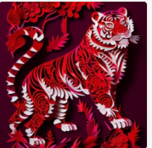
paper cut craft, paper illustration, chinese new year, dog, full body, colorful, very detailed, 8k --q 2 --upbeta --v 4 | 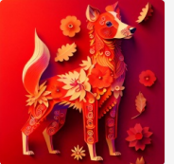
paper cut craft, paper illustration, chinese new year, horse, colorful, very detailed, 8k --q 2 --upbeta --v 4 | 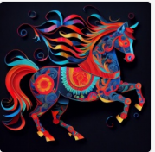
paper cut craft, paper illustration, chinese new year, pig, colorful, very detailed, 8k --q 2 --upbeta --v 4 | 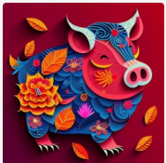
Gorgeous and lovely Chinese zodiac pig. Its crystal ice hair is like snow, and it is as charming as Chinese snowflakes. Its super fine fur, turquoise red eyes, whole body, turquoise base, jewelry, complex details, movie lights, gold design, illusory engine, octane rendering, mad consul Peter Morbach, Jordan Grimmer, cattle atmospheric aperture, magic aperture, Fantasy aperture, flame aperture, cow marks the rainbow bridge to heaven, light and dark, the corner of hell, high-definition aesthetic pictures, high-definition, 4k high-definition, ultra-high definition, 3d rendering, virtual engine, very detailed --v 4 | 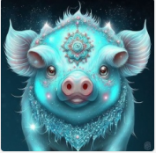
Gorgeous and lovely Chinese zodiac dog. Its crystal ice hair is like snow, and it is as charming as Chinese snowflakes. Its super fine fur, turquoise red eyes, whole body, turquoise base, jewelry, complex details, movie lights, gold design, illusory engine, octane rendering, mad consul Peter Morbach, Jordan Grimmer, cattle atmospheric aperture, magic aperture, Fantasy aperture, flame aperture, cow marks the rainbow bridge to heaven, light and dark, the corner of hell, high-definition aesthetic pictures, high-definition, 4k high-definition, ultra-high definition, 3d rendering, virtual engine, very detailed --ar 1:1 --v 4 --upbeta | 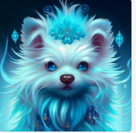
Gorgeous and lovely Chinese zodiac tiger. Its crystal ice hair is like snow, and it is as charming as Chinese snowflakes. Its super fine fur, turquoise red eyes, whole body, turquoise base, jewelry, complex details, movie lights, gold design, illusory engine, octane rendering, mad consul Peter Morbach, Jordan Grimmer, cattle atmospheric aperture, magic aperture, Fantasy aperture, flame aperture, cow marks the rainbow bridge to heaven, light and dark, the corner of hell, high-definition aesthetic pictures, high-definition, 4k high-definition, ultra-high definition, 3d rendering, virtual engine, very detailed --v 4 --v 4 | 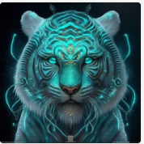
Gorgeous and lovely Chinese zodiac dragon. Its crystal ice hair is like snow, and it is as charming as Chinese snowflakes. Its super fine fur, turquoise red eyes, whole body, turquoise base, jewelry, complex details, movie lights, gold design, illusory engine, octane rendering, mad consul Peter Morbach, Jordan Grimmer, cattle atmospheric aperture, magic aperture, Fantasy aperture, flame aperture, cow marks the rainbow bridge to heaven, light and dark, the corner of hell, high-definition aesthetic pictures, high-definition, 4k high-definition, ultra-high definition, 3d rendering, virtual engine, very detailed --v 4 --v 4 | 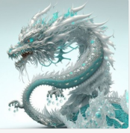
Gorgeous and lovely Chinese zodiac rabbit. Its crystal ice hair is like snow, and it is as charming as Chinese snowflakes. Its super fine fur, turquoise red eyes, whole body, turquoise base, jewelry, complex details, movie lights, gold design, illusory engine, octane rendering, mad consul Peter Morbach, Jordan Grimmer, cattle atmospheric aperture, magic aperture, Fantasy aperture, flame aperture, cow marks the rainbow bridge to heaven, light and dark, the corner of hell, high-definition aesthetic pictures, high-definition, 4k high-definition, ultra-high definition, 3d rendering, virtual engine, very detailed --v 4 --v 4 | 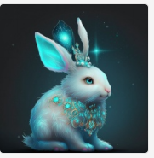
gorgeous and lovely chinese zodiac chicken. its crystal ice hair is like snow, and it is as charming as chinese snowflakes its super fine fur, turquoise red eyes, whole body, turquoise base, jewelry, complex details, movie lights, gold design, illusory engine, octane rendering, mad consul peter morbach, jordan grimmer, cattle atmospheric aperture, magic aperture, fantasy aperture, flame aperture, cat marks the rainbow bridge to heaven, light and dark, the corner of hell, highdefinition aesthetic pi --v 4 | 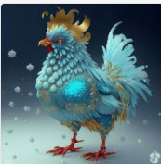
A green cute vegetable monkey, monkey made from a Mosaic of different vegetables, movie lighting, art illustration style, big eyes, around vegetables and fruits, charming, glossy feel, Unreal Engine 5 and Octane rendering, 4k, popular on artstation, gorgeous, super wide Angle, 8k, --v 4 | 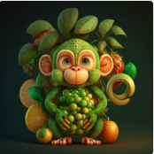
A green cute vegetable dragon, dragon made from a Mosaic of different vegetables, movie lighting, art illustration style, big eyes, around vegetables and fruits, charming, glossy feel, Unreal Engine 5 and Octane rendering, 4k, popular on artstation, gorgeous, super wide Angle, 8k, --v 4 | 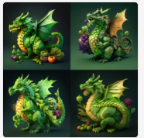
A green cute vegetable pig, pig made from a Mosaic of different vegetables, movie lighting, art illustration style, big eyes, around vegetables and fruits, charming, glossy feel, Unreal Engine 5 and Octane rendering, 4k, popular on artstation, gorgeous, super wide Angle, 8k, --v 4 | 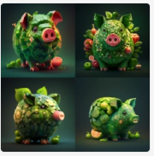
A green cute vegetable dog, dog made from a Mosaic of different vegetables, movie lighting, art illustration style, big eyes, around vegetables and fruits, charming, glossy feel, Unreal Engine 5 and Octane rendering, 4k, popular on artstation, gorgeous, super wide Angle, 8k, --v 4 | 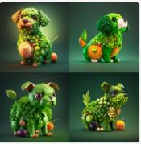
A green cute vegetable sheep, sheep made from a Mosaic of different vegetables, movie lighting, art illustration style, big eyes, around vegetables and fruits, charming, glossy feel, Unreal Engine 5 and Octane rendering, 4k, popular on artstation, gorgeous, super wide Angle, 8k, --v 4 | 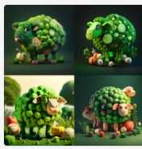
A green cute vegetable horse, horse made from a Mosaic of different vegetables, movie lighting, art illustration style, big eyes, around vegetables and fruits, charming, glossy feel, Unreal Engine 5 and Octane rendering, 4k, popular on artstation, gorgeous, super wide Angle, 8k, --v 4 | 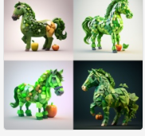
A green cute vegetable snake, snake made from a Mosaic of different vegetables, movie lighting, art illustration style, big eyes, around vegetables and fruits, charming, glossy feel, Unreal Engine 5 and Octane rendering, 4k, popular on artstation, gorgeous, super wide Angle, 8k, --v 4 | 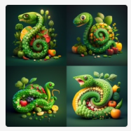
A green cute vegetable dragon, dragon made from a Mosaic of different vegetables, movie lighting, art illustration style, big eyes, around vegetables and fruits, charming, glossy feel, Unreal Engine 5 and Octane rendering, 4k, popular on artstation, gorgeous, super wide Angle, 8k, --v 4 | 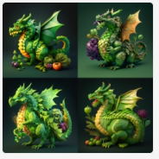
A green cute vegetable tiger, tiger made from a Mosaic of different vegetables, movie lighting, art illustration style, big eyes, around vegetables and fruits, charming, glossy feel, Unreal Engine 5 and Octane rendering, 4k, popular on artstation, gorgeous, super wide Angle, 8k, --v 4 | 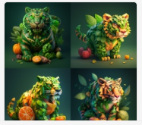
A green cute vegetable rabbit, rabbit made from a Mosaic of different vegetables, movie lighting, art illustration style, big eyes, around vegetables and fruits, charming, glossy feel, Unreal Engine 5 and Octane rendering, 4k, popular on artstation, gorgeous, super wide Angle, 8k, --v 4 | 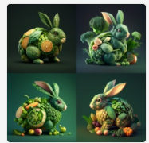
A green cute vegetable cow, cow made from a Mosaic of different vegetables, movie lighting, art illustration style, big eyes, around vegetables and fruits, charming, glossy feel, Unreal Engine 5 and Octane rendering, 4k, popular on artstation, gorgeous, super wide Angle, 8k, --v 4 | 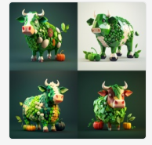
A green cute vegetable mouse, mouse made from a Mosaic of different vegetables, movie lighting, art illustration style, big eyes, around vegetables and fruits, charming, glossy feel, Unreal Engine 5 and Octane rendering, 4k, popular on artstation, gorgeous, super wide Angle, 8k, --v 4 | 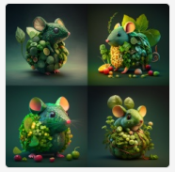
A green cute vegetable chicken, chicken made from a Mosaic of different vegetables, movie lighting, art illustration style, big eyes, around vegetables and fruits, charming, glossy feel, Unreal Engine 5 and Octane rendering, 4k, popular on artstation, gorgeous, super wide Angle, 8k, --v 4 | 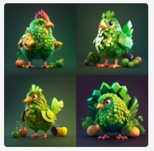
A cute personification baby pig, on the scene of the world cup football match, dressed in a red football suit and shorts, facing his football feet, was bright white and fluffy, big eyes bright, sweet smile, fluffy tail, extremely detailed 3d animation translation symmetrical center position, super realistic, super detailed, super clear details, super clear materials, closeup shots, complex textures, unreal engine5, octane translation, zbrush, 8k, vr ay surreal, --v 4 --upbeta | 
A cute personification baby chicken, on the scene of the world cup football match, dressed in a red football suit and shorts, facing his football feet, was bright white and fluffy, big eyes bright, sweet smile, fluffy tail, extremely detailed 3d animation translation symmetrical center position, super realistic, super detailed, super clear details, super clear materials, closeup shots, complex textures, unreal engine5, octane translation, zbrush, 8k, vr ay surreal, --v 4 --upbeta | 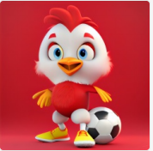
A cute personification baby dragon, on the scene of the world cup football match, dressed in a red football suit and shorts, facing his football feet, was bright white and fluffy, big eyes bright, sweet smile, fluffy tail, extremely detailed 3d animation translation symmetrical center position, super realistic, super detailed, super clear details, super clear materials, closeup shots, complex textures, unreal engine5, octane translation, zbrush, 8k, vr ay surreal, --v 4 --upbeta | 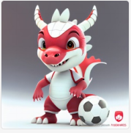
A cute personification baby snake, on the scene of the world cup football match, dressed in a red football suit and shorts, facing his football feet, was bright white and fluffy, big eyes bright, sweet smile, fluffy tail, extremely detailed 3d animation translation symmetrical center position, super realistic, super detailed, super clear details, super clear materials, closeup shots, complex textures, unreal engine5, octane translation, zbrush, 8k, vr ay surreal, --v 4 --upbeta | 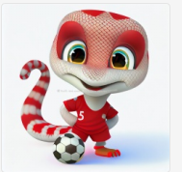
A cute personification baby sheep, on the scene of the world cup football match, dressed in a red football suit and shorts, facing his football feet, was bright white and fluffy, big eyes bright, sweet smile, fluffy tail, extremely detailed 3d animation translation symmetrical center position, super realistic, super detailed, super clear details, super clear materials, closeup shots, complex textures, unreal engine5, octane translation, zbrush, 8k, vr ay surreal, --v 4 --upbeta | 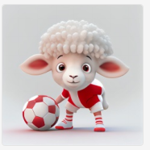
A cute personification baby monkey, on the scene of the world cup football match, dressed in a red football suit and shorts, facing his football feet, was bright white and fluffy, big eyes bright, sweet smile, fluffy tail, extremely detailed 3d animation translation symmetrical center position, super realistic, super detailed, super clear details, super clear materials, closeup shots, complex textures, unreal engine5, octane translation, zbrush, 8k, vr ay surreal, --v 4 --upbeta | 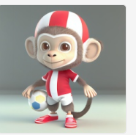
A cute personification baby tiger, on the scene of the world cup football match, dressed in a red football suit and shorts, facing his football feet, was bright white and fluffy, big eyes bright, sweet smile, fluffy tail, extremely detailed 3d animation translation symmetrical center position, super realistic, super detailed, super clear details, super clear materials, closeup shots, complex textures, unreal engine5, octane translation, zbrush, 8k, vr ay surreal, --v 4 --upbeta | 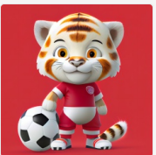
A cute personification baby rabbit, on the scene of the world cup football match, dressed in a red football suit and shorts, facing his football feet, was bright white and fluffy, big eyes bright, sweet smile, fluffy tail, extremely detailed 3d animation translation symmetrical center position, super realistic, super detailed, super clear details, super clear materials, closeup shots, complex textures, unreal engine5, octane translation, zbrush, 8k, vr ay surreal, --v 4 --upbeta | 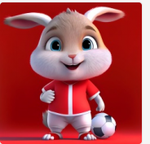
A cute personification baby mouse, on the scene of the world cup football match, dressed in a red football suit and shorts, facing his football feet, was bright white and fluffy, big eyes bright, sweet smile, fluffy tail, extremely detailed 3d animation translation symmetrical center position, super realistic, super detailed, super clear details, super clear materials, closeup shots, complex textures, unreal engine5, octane translation, zbrush, 8k, vr ay surreal, --v 4 --upbeta | 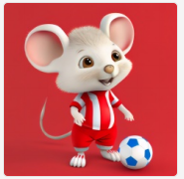
A cute personification baby dog, on the scene of the world cup football match, dressed in a red football suit and shorts, facing his football feet, was bright white and fluffy, big eyes bright, sweet smile, fluffy tail, extremely detailed 3d animation translation symmetrical center position, super realistic, super detailed, super clear details, super clear materials, closeup shots, complex textures, unreal engine5, octane translation, zbrush, 8k, vr ay surreal, --v 4 --upbeta | 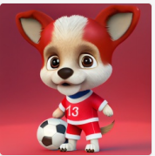
A cute personification horse,on the scene of the world cup football match, dressed in a red football suit and shorts, facing his football feet, was bright white and fluffy, big eyes bright, sweet smile, fluffy tail, extremely detailed 3d animation translation symmetrical center position, super realistic, super detailed, super clear details, super clear materials, closeup shots, complex textures, unreal engine5, octane translation, zbrush, 8k, vr ay surreal, --v 4 --upbeta | 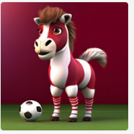
papercut craft, mouse, cute, cute high definition --v 4 | 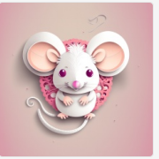
papercut craft, rabbit, cute, cute high definition --v 4 | 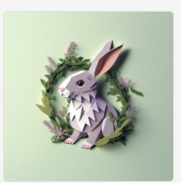
papercut craft, pony, cute, cute high definition --v 4 | 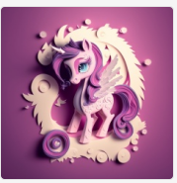
papercut craft, sheep, cute, cute high definition --v 4 | 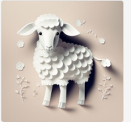
papercut craft, Chinese dragon, cute, cute high definition --v 4 | 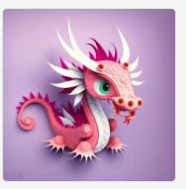
papercut craft, baby dog, cute, cute high definition --v 4 | 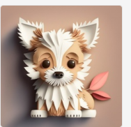
papercut craft, white baby tiger, cute, cute high definition --v 4 | 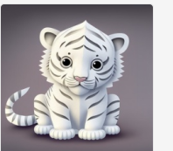
papercut craft,baby pig , cute, cute high definition --v 4 | 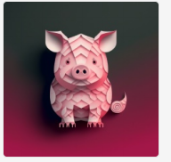
papercut craft, chicken, cute, cute high definition --v 4 | 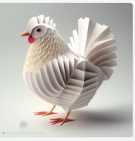
papercut craft,cow, cute, cute high definition --v 4 | 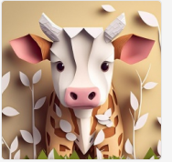
Cartoon character design,cute anthropomorphic tiger baby , The body is polished white jade, lts crystal ice hair islike snow, and it is as charming as chinese snowflakes lts super fine fur,Super delicate head, turquoise eyes,Ultra-detailed scales,Ultra-fine fur texture, Wearing gorgeous jewelry on the head, the whole body looks very lovely，Long view composition, full body front，jewelry, complex details, movie lights, gold design, ilusory engine, octane rendering, mad consul peter morbach, jordangrimmer, cattle atmospheric aperture, magic aperture, fantasyaperture, flame aperture, cow marks the rainbow bridge to heaven, light and dark, the corner of hell, high-definition aesthetic pictures, high-definition, 4k high-definition, ultra-highdefinition, 3d rendering, Jadeite,virtual engine, super detailed, realistic octane render 8k --ar 2:3 --v 4 --upbeta | 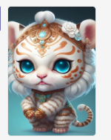
Cartoon character design,cute anthropomorphic bunny baby , The body is polished white jade, lts crystal ice hair islike snow, and it is as charming as chinese snowflakes lts super fine fur,Super delicate head, turquoise eyes,Ultra-detailed scales,Ultra-fine fur texture, Wearing gorgeous jewelry on the head, the whole body looks very lovely，Long view composition, full body front，jewelry, complex details, movie lights, gold design, ilusory engine, octane rendering, mad consul peter morbach, jordangrimmer, cattle atmospheric aperture, magic aperture, fantasyaperture, flame aperture, cow marks the rainbow bridge to heaven, light and dark, the corner of hell, high-definition aesthetic pictures, high-definition, 4k high-definition, ultra-highdefinition, 3d rendering, Jadeite,virtual engine, super detailed, realistic octane render 8k --ar 2:3 --v 4 --upbeta | 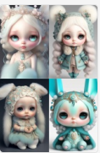
Cartoon character design,cute anthropomorphic cattle baby , The body is polished white jade, lts crystal ice hair islike snow, and it is as charming as chinese snowflakes lts super fine fur,Super delicate head, turquoise eyes,Ultra-detailed scales,Ultra-fine fur texture, Wearing gorgeous jewelry on the head, the whole body looks very lovely,Long view composition, full body front,jewelry, complex details, movie lights, gold design, ilusory engine, octane rendering, mad consul peter morbach, jordangrimmer, cattle atmospheric aperture, magic aperture, fantasyaperture, flame aperture, cow marks the rainbow bridge to heaven, light and dark, the corner of hell, high-definition aesthetic pictures, high-definition, 4k high-definition, ultra-highdefinition, 3d rendering, Jadeite,virtual engine, super detailed, realistic octane render 8k --ar 2:3 --v 4 --upbeta | 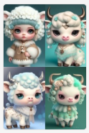
Cartoon character design,cute anthropomorphic dog baby , The body is polished white jade, lts crystal ice hair islike snow, and it is as charming as chinese snowflakes lts super fine fur,Super delicate head, turquoise eyes,Ultra-detailed scales,Ultra-fine fur texture, Wearing gorgeous jewelry on the head, the whole body looks very lovely,Long view composition, full body front,jewelry, complex details, movie lights, gold design, ilusory engine, octane rendering, mad consul peter morbach, jordangrimmer, cattle atmospheric aperture, magic aperture, fantasyaperture, flame aperture, cow marks the rainbow bridge to heaven, light and dark, the corner of hell, high-definition aesthetic pictures, high-definition, 4k high-definition, ultra-highdefinition, 3d rendering, Jadeite,virtual engine, super detailed, realistic octane render 8k --ar 2:3 --v 4 --upbeta | 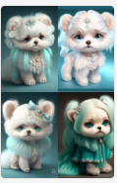
Cartoon character design,cute anthropomorphic Chinese dragon baby , The body is polished white jade, lts crystal ice hair islike snow, and it is as charming as chinese snowflakes lts super fine fur,Super delicate head, turquoise eyes,Ultra-detailed scales,Ultra-fine fur texture, Wearing gorgeous jewelry on the head, the whole body looks very lovely,Long view composition, full body front,jewelry, complex details, movie lights, gold design, ilusory engine, octane rendering, mad consul peter morbach, jordangrimmer, cattle atmospheric aperture, magic aperture, fantasyaperture, flame aperture, cow marks the rainbow bridge to heaven, light and dark, the corner of hell, high-definition aesthetic pictures, high-definition, 4k high-definition, ultra-highdefinition, 3d rendering, Jadeite,virtual engine, super detailed, realistic octane render 8k --ar 2:3 --v 4 --upbeta | 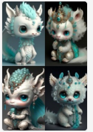
Cartoon character design,cute anthropomorphic pig baby , The body is polished white jade, lts crystal ice hair islike snow, and it is as charming as chinese snowflakes lts super fine fur,Super delicate head, turquoise eyes,Ultra-detailed scales,Ultra-fine fur texture, Wearing gorgeous jewelry on the head, the whole body looks very lovely,Long view composition, full body front,jewelry, complex details, movie lights, gold design, ilusory engine, octane rendering, mad consul peter morbach, jordangrimmer, cattle atmospheric aperture, magic aperture, fantasyaperture, flame aperture, cow marks the rainbow bridge to heaven, light and dark, the corner of hell, high-definition aesthetic pictures, high-definition, 4k high-definition, ultra-highdefinition, 3d rendering, Jadeite,virtual engine, super detailed, realistic octane render 8k --ar 2:3 --v 4 --upbeta | 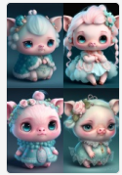
Cartoon character design,cute anthropomorphic chicken baby , The body is polished white jade, lts crystal ice hair islike snow, and it is as charming as chinese snowflakes lts super fine fur,Super delicate head, turquoise eyes,Ultra-detailed scales,Ultra-fine fur texture, Wearing gorgeous jewelry on the head, the whole body looks very lovely,Long view composition, full body front,jewelry, complex details, movie lights, gold design, ilusory engine, octane rendering, mad consul peter morbach, jordangrimmer, cattle atmospheric aperture, magic aperture, fantasyaperture, flame aperture, cow marks the rainbow bridge to heaven, light and dark, the corner of hell, high-definition aesthetic pictures, high-definition, 4k high-definition, ultra-highdefinition, 3d rendering, Jadeite,virtual engine, super detailed, realistic octane render 8k --ar 2:3 --v 4 --upbeta | 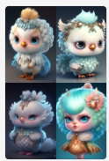
Cartoon character design,cute anthropomorphic monkey baby , The body is polished white jade, lts crystal ice hair islike snow, and it is as charming as chinese snowflakes lts super fine fur,Super delicate head, turquoise eyes,Ultra-detailed scales,Ultra-fine fur texture, Wearing gorgeous jewelry on the head, the whole body looks very lovely,Long view composition, full body front,jewelry, complex details, movie lights, gold design, ilusory engine, octane rendering, mad consul peter morbach, jordangrimmer, cattle atmospheric aperture, magic aperture, fantasyaperture, flame aperture, cow marks the rainbow bridge to heaven, light and dark, the corner of hell, high-definition aesthetic pictures, high-definition, 4k high-definition, ultra-highdefinition, 3d rendering, Jadeite,virtual engine, super detailed, realistic octane render 8k --ar 2:3 --v 4 --upbeta | 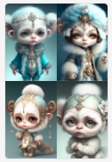
Cartoon character design,cute anthropomorphic sheep baby , The body is polished white jade, lts crystal ice hair islike snow, and it is as charming as chinese snowflakes lts super fine fur,Super delicate head, turquoise eyes,Ultra-detailed scales,Ultra-fine fur texture, Wearing gorgeous jewelry on the head, the whole body looks very lovely,Long view composition, full body front,jewelry, complex details, movie lights, gold design, ilusory engine, octane rendering, mad consul peter morbach, jordangrimmer, cattle atmospheric aperture, magic aperture, fantasyaperture, flame aperture, cow marks the rainbow bridge to heaven, light and dark, the corner of hell, high-definition aesthetic pictures, high-definition, 4k high-definition, ultra-highdefinition, 3d rendering, Jadeite,virtual engine, super detailed, realistic octane render 8k --ar 2:3 --v 4 --upbeta | 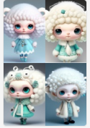
Cartoon character design,cute anthropomorphic snake baby , The body is polished white jade, lts crystal ice hair islike snow, and it is as charming as chinese snowflakes lts super fine fur,Super delicate head, turquoise eyes,Ultra-detailed scales,Ultra-fine fur texture, Wearing gorgeous jewelry on the head, the whole body looks very lovely,Long view composition, full body front,jewelry, complex details, movie lights, gold design, ilusory engine, octane rendering, mad consul peter morbach, jordangrimmer, cattle atmospheric aperture, magic aperture, fantasyaperture, flame aperture, cow marks the rainbow bridge to heaven, light and dark, the corner of hell, high-definition aesthetic pictures, high-definition, 4k high-definition, ultra-highdefinition, 3d rendering, Jadeite,virtual engine, super detailed, realistic octane render 8k --ar 2:3 --v 4 --upbeta | 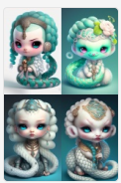
Cartoon character design,cute anthropomorphic mouse baby , The body is polished white jade, lts crystal ice hair islike snow, and it is as charming as chinese snowflakes lts super fine fur,Super delicate head, turquoise eyes,Ultra-detailed scales,Ultra-fine fur texture, Wearing gorgeous jewelry on the head, the whole body looks very lovely,Long view composition, full body front,jewelry, complex details, movie lights, gold design, ilusory engine, octane rendering, mad consul peter morbach, jordangrimmer, cattle atmospheric aperture, magic aperture, fantasyaperture, flame aperture, cow marks the rainbow bridge to heaven, light and dark, the corner of hell, high-definition aesthetic pictures, high-definition, 4k high-definition, ultra-highdefinition, 3d rendering, Jadeite,virtual engine, super detailed, realistic octane render 8k --ar 2:3 --v 4 --upbeta | 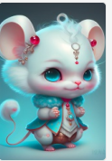
Cartoon character design,cute anthropomorphic pony baby , The body is polished white jade, lts crystal ice hair islike snow, and it is as charming as chinese snowflakes lts super fine fur,Super delicate head, turquoise eyes,Ultra-detailed scales,Ultra-fine fur texture, Wearing gorgeous jewelry on the head, the whole body looks very lovely,Long view composition, full body front,jewelry, complex details, movie lights, gold design, ilusory engine, octane rendering, mad consul peter morbach, jordangrimmer, cattle atmospheric aperture, magic aperture, fantasyaperture, flame aperture, cow marks the rainbow bridge to heaven, light and dark, the corner of hell, high-definition aesthetic pictures, high-definition, 4k high-definition, ultra-highdefinition, 3d rendering, Jadeite,virtual engine, super detailed, realistic octane render 8k --ar 2:3 --v 4 --upbeta | 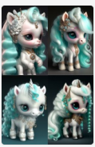
A winter full of regret, Drifting snow, A super cute baby pixar style white fairy pig, shiny snow-white fluffy, big bright eyes, fluffy tail, wearing a blue sweater, wearing pink a hat, smile，delicate and fine, fairy tales, incredibly high detailed, Pixar style, bright color , Natural light, Simple background with pure color,5 and Octane Render, trending on artstation, Gorgeous,ultra wide angle, 8K,hd realistic, 8K Hd --ar 2:3 --v 4 | 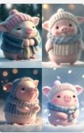
A winter full of regret, Drifting snow, A super cute baby pixar style white fairy puppy, shiny snow-white fluffy, big bright eyes, fluffy tail, wearing a blue sweater, wearing pink a hat, smile，delicate and fine, fairy tales, incredibly high detailed, Pixar style, bright color , Natural light, Simple background with pure color,5 and Octane Render, trending on artstation, Gorgeous,ultra wide angle, 8K,hd realistic, 8K Hd --ar 2:3 --v 4 | 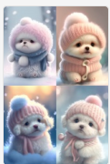
A winter full of regret, Drifting snow, A super cute baby pixar style white fairy monkey, shiny snow-white fluffy, big bright eyes, fluffy tail, wearing a blue sweater, wearing pink a hat, smile，delicate and fine, fairy tales, incredibly high detailed, Pixar style, bright color , Natural light, Simple background with pure color,5 and Octane Render, trending on artstation, Gorgeous,ultra wide angle, 8K,hd realistic, 8K Hd --ar 2:3 --v 4 | 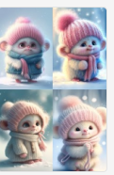
A winter full of regret, Drifting snow, A super cute baby pixar style white fairy tiger, shiny snow-white fluffy, big bright eyes, fluffy tail, wearing a blue sweater, wearing pink a hat, smile，delicate and fine, fairy tales, incredibly high detailed, Pixar style, bright color , Natural light, Simple background with pure color,5 and Octane Render, trending on artstation, Gorgeous,ultra wide angle, 8K,hd realistic, 8K Hd --ar 2:3 --v 4 | 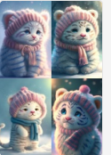
A winter full of regret, Drifting snow, A super cute baby pixar style white fairy sheep, shiny snow-white fluffy, big bright eyes, fluffy tail, wearing a blue sweater, wearing pink a hat, smile，delicate and fine, fairy tales, incredibly high detailed, Pixar style, bright color , Natural light, Simple background with pure color,5 and Octane Render, trending on artstation, Gorgeous,ultra wide angle, 8K,hd realistic, 8K Hd --ar 2:3 --v 4 | 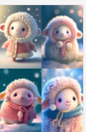
A winter full of regret, Drifting snow, A super cute baby pixar style white fairy chinese dragon, shiny snow-white fluffy, big bright eyes, fluffy tail, wearing a blue sweater, wearing pink a hat, smile，delicate and fine, fairy tales, incredibly high detailed, Pixar style, bright color , Natural light, Simple background with pure color,5 and Octane Render, trending on artstation, Gorgeous,ultra wide angle, 8K,hd realistic, 8K Hd --ar 2:3 --v 4 | 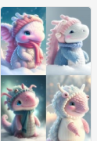
A winter full of regret, Drifting snow, A super cute baby pixar style white fairy pony, shiny snow-white fluffy, big bright eyes, fluffy tail, wearing a blue sweater, wearing pink a hat, smile，delicate and fine, fairy tales, incredibly high detailed, Pixar style, bright color , Natural light, Simple background with pure color,5 and Octane Render, trending on artstation, Gorgeous,ultra wide angle, 8K,hd realistic, 8K Hd --ar 2:3 --v 4 | 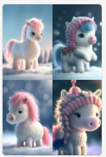
A winter full of regret, Drifting snow, A super cute baby pixar style white fairy rabbit, shiny snow-white fluffy, big bright eyes, fluffy tail, wearing a blue sweater, wearing pink a hat, smile，delicate and fine, fairy tales, incredibly high detailed, Pixar style, bright color , Natural light, Simple background with pure color,5 and Octane Render, trending on artstation, Gorgeous,ultra wide angle, 8K,hd realistic, 8K Hd --ar 2:3 --v 4 | 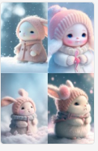
A winter full of regret, Drifting snow, A super cute baby pixar style white fairy snake, shiny snow-white fluffy, big bright eyes, fluffy tail, wearing a blue sweater, wearing pink a hat, smile，delicate and fine, fairy tales, incredibly high detailed, Pixar style, bright color , Natural light, Simple background with pure color,5 and Octane Render, trending on artstation, Gorgeous,ultra wide angle, 8K,hd realistic, 8K Hd --ar 2:3 --v 4 | 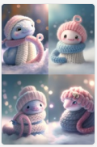
A winter full of regret, Drifting snow, A super cute baby pixar style white fairy cattle, shiny snow-white fluffy, big bright eyes, fluffy tail, wearing a blue sweater, wearing pink a hat, smile，delicate and fine, fairy tales, incredibly high detailed, Pixar style, bright color , Natural light, Simple background with pure color,5 and Octane Render, trending on artstation, Gorgeous,ultra wide angle, 8K,hd realistic, 8K Hd --ar 2:3 --v 4 | 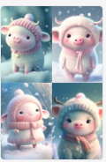
A winter full of regret, Drifting snow, A super cute baby pixar style white fairy chicken, shiny snow-white fluffy, big bright eyes, fluffy tail, wearing a blue sweater, wearing pink a hat, smile，delicate and fine, fairy tales, incredibly high detailed, Pixar style, bright color , Natural light, Simple background with pure color,5 and Octane Render, trending on artstation, Gorgeous,ultra wide angle, 8K,hd realistic, 8K Hd --ar 2:3 --v 4 | 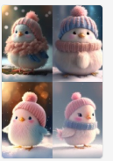
A winter full of regret, Drifting snow, A super cute baby pixar style white fairy mouse, shiny snow-white fluffy, big bright eyes, fluffy tail, wearing a blue sweater, wearing pink a hat, smile，delicate and fine, fairy tales, incredibly high detailed, Pixar style, bright color , Natural light, Simple background with pure color,5 and Octane Render, trending on artstation, Gorgeous,ultra wide angle, 8K,hd realistic, 8K Hd --ar 2:3 --v 4 | 