Plush baby sheep cloth + sweet smile + holding a red lantern, Standing In Snow, Kawaii, Sanrio, Modern, Full Body, 3D Portrait, Classic Pastel Color Scheme, Side Glimpse Of Fine Intricate Details, Photorealistic, Unreal Engine 5, Octane Return, 8K, Smooth Blender --v 4 --upbeta | 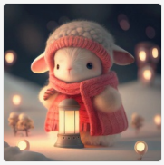
Front view, 3D, on winter morning, small and cute anthropomorphic white tiger cub, wearing a cute plush hat, Chinese pink and blue school uniform, full body, standing, symmetrical ears, bright big eyes, sweet smile, riding a bicycle, Christmas scene, fluffy snow, complex hairy details, soft movie lighting, 8k, portrait, Pokémon animation style, octane rendering, unreal engine rendering, high quality --q 2 --ar 2:3 --v 4 | 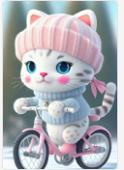
3D, on winter morning, small and cute anthropomorphic white rabbit cub, wearing a cute plush hat, Chinese pink and blue school uniform, full body,sitting on a swing , symmetrical ears, bright big eyes, sweet smile, Christmas scene, fluffy snow, complex hairy details, soft movie lighting, 8k, portrait, Pokémon animation style, octane rendering, unreal engine rendering, high quality,8k realistic --v 4 --ar 2:3 | 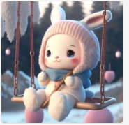
a super cute baby pixar style white fairy rabbit, Happy smile, silly, sweet smile,shiny snow white fluffy, big bright eyes, fluffy tail, wearing a ice blue pink sweater, wearing a hat,a happy smile and a bland expression rising spring sun, sweet smilefairy tales, charming, illusory engine 5 and octane render ,ureal --ar 2:3 --v 4 --upbeta | 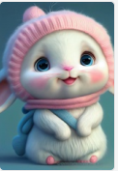
A super cute baby pixar style white fairy rabbit, shiny snow-white fluffy, big bright eyes, fluffy tail, wearing a blue sweater, wearing pink a hat and sunglasses, smile，delicate and fine, fairy tales, incredibly high detailed, Pixar style, bright color , Natural light, Simple background with pure color,5 and Octane Render, trending on artstation, Gorgeous,ultra wide angle, 8K,hd realistic, 8K Hd --ar 2:3 --q 2 --v 4 | 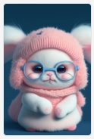
A winter full of regret, Drifting snow, A super cute baby pixar style white fairy rabbit, shiny snow-white fluffy, big bright eyes, fluffy tail, wearing a blue sweater, wearing pink a hat, smile，delicate and fine, fairy tales, incredibly high detailed, Pixar style, bright color , Natural light, Simple background with pure color,5 and Octane Render, trending on artstation, Gorgeous,ultra wide angle, 8K,hd realistic, 8K Hd --ar 2:3 --v 4 | 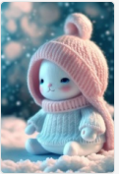
A winter full of regret, Drifting snow, A super cute baby pixar style white fairy rabbit, shiny snow-white fluffy, big bright eyes, fluffy tail, wearing a blue sweater, wearing green a hat, smile，delicate and fine, fairy tales, incredibly high detailed, Pixar style, bright color , Natural light, Simple background with pure color,5 and Octane Render, trending on artstation, Gorgeous,ultra wide angle, 8K,hd realistic ureal, 8K Hd --ar 2:3 --v 4 | 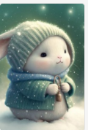
pixar style, the highest quality, chibi,full body, 32k super clear, the most complicated details, clear and complex texture, q character theme, clear focus, a little rabbit, meticulous casual wear, exquisite sneakers meticulous eye depiction, 3d highreflective large eyes, ultrawideangle lens, flying starlight, meticulous leg depiction, meticulous hand portrayal, evening starry sky, moon, ultra hd, 8k, ultimate detail, professional volumetric lighting, exquisite cg, dazzling engine, bloom, tyndall effect, light particles, volumetric lighting, --v 4 | 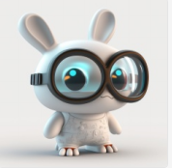
High quality 3D rendering, surrealism, very cute, soft color, Doraemon, space travel, space suit, very detailed, smooth vray, the same as Hannah Yata Charlie Immer. Soft indoor light, low angle, ultra-high definition 8k, sharp focus, high-definition --v 4 --upbeta | 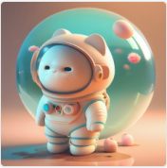
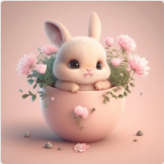 | A baby light pink rabbit, super super cute, in the cup, big eyes, small daisies around, clean sunshine, enchanting, hairy, shiny mane, petals, fairy tales, Pixar style, happy smile, personification, trend art station, virtual engine 5 and octane rendering, 8K, high-definition, hd ureal realistic --v 4
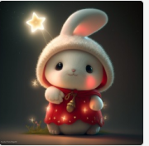 | A super cute baby pixar style white fairy rabbit,wearing a red coat, a cute hat, hold a shining star lamp high, pixar style, shiny white fluffy, bright big eyes, hairy tail, fairy tale, charming, and illusory engine 5 rendering 8k, stars all over the sky,glowing fireflies,prospect,intricately detailed, hyperdetailed, hyperrealistic, magical lighting, hd, outlines, blur, dynamic composition, wide angle, ghibli cinematic, studio ghibli illustration, ayami kojima, cinematic, super detailed, realistic octane render 8k upbeta --v 4
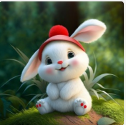 | A super cute baby pixar style white fairy rabbit with smile,with two cute ears,shiny snow-white fluffy, big bright eyes, fluffy tail, Smiling and sitting on,wearing a red hat,delicate and fine, fairy tales, incredibly high detailed, Pixar style, bright color , Natural light, Simple background with pure color,Wide Chest, Full Length Portrait,5 and Octane Render, trending on artstation, Gorgeous,ultra wide angle, 8K,hd realistic --v 4
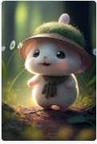 | in summer,a super cute baby pixar style white fairy rabbit, big eyed rabbit laughing happily and walking in a forest, Wearing a green vest with hat, Open mouth, shiny snow white fluffy, big bright eyes, fat, fluffy tail,full character concept, rainbow light, trending on artstation, matte painting,fairy tales, charming, illusory engine 5 and octane render --ar 2:3 --v 4 --upbeta --q 2
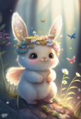 | in spring,a super cute baby pixar style white fairy rabbit, big eyed rabbit laughing happily and walking in a forest, Wearing a coat made of flowers, Garlands on its head, Open mouth, shiny snow white fluffy, big bright eyes, fat, fluffy tail,full character concept, rainbow light, trending on artstation, matte painting,fairy tales, charming, illusory engine 5 and octane render --ar 2:3 --v 4 --upbeta --q 2
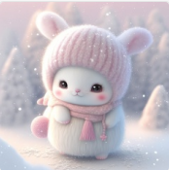 | A beautiful winter full of snow, a super cute white fairy tale rabbit in elf style, shiny snow-white fluff, beautiful bright big eyes, fluffy tail, slim and small figure, wearing a pink hat and scarf, sweet smile, delicate and delicate, fairy tale, incredible high detail, Pixar style, bright color, natural light, simple background of solid color, 5 and Octane Render, Popular on art stations, gorgeous, super wide angle, 8K, high-definition lifelike --v 4
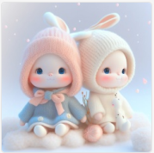 | A winter full of regret, Drifting snow, two cute and sweet baby pixar style white fairy rabbit, shiny snow-white fluffy, big big bright eyes, fluffy tail, wearing a blue sweater, wearing pink a hat, smile，delicate and fine, fairy tales, incredibly high detailed, Pixar style, bright color , Natural light, Simple background with pure color,5 and Octane Render, trending on artstation, Gorgeous,ultra wide angle, 8K,hd realistic --v 4
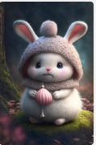 | a super cute baby pixar style white fairy rabbit, shiny snow white fluffy, big bright eyes, fluffy tail, wearing a sweater, wearing a lovely candy hat, magic candy forest, fairy tales, charming, illusory engine 5 and octane render v 4 --v 4 --ar 2:3
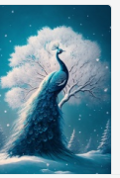 | This is a beautiful snow scene. A beautiful blue peacock, whose feathers are shiny and smooth, and a big tree covered with snow. The background is light blue, surreal, super wide angle, photography, bright and soft lights, beautiful artistic conception, 4K high-definition --ar 2:3 --v 4
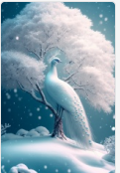 | This is a beautiful snow scene. A beautiful white peacock, whose feathers are shiny and smooth, and a big tree covered with snow. The background is light blue, surreal, super wide angle, photography, bright and soft lights, beautiful artistic conception, 4K high-definition --ar 2:3 --v 4
Front view, 3D, a small and lovely anthropomorphic white rabbit cub, shiny white fluffy, bright big eyes, symmetrical ears, wearing a green coat and white hat, delicate and delicate smile, fairy tales, incredibly high details, bright colors, natural light, simple background, 5 and octane number rendering, trends on artstation, Poké mon animation style, gorgeous, 8K, high-definition and realistic. --v 4 --q 2 | 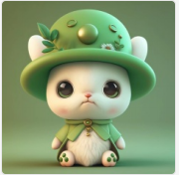
This is a CG rendering of a beautiful painting, a beautiful white peacock on the blue beach by the sea, white feathers, smooth and delicate feathers, sunshine, ultra wide Angle of view, ocean volume of sunshine light, surrealism, ultra wide Angle of view, ultra wide field of view, and ultra HD quality, 8K, high detail, octane rendering, extreme long lens, beautiful lighting, ureal --ar 2:3 --v 4 --q 2 | 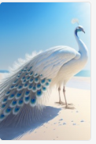
at night, On the golden White beach, there is a beautiful peacock on the sparkling beach. The peacock stands on the smooth and transparent stone, surrounded by white. They are smooth, transparent, oval, love shaped, crystal clear, solid and transparent, galaxy, starry sky, waves, ultra clear 8K, ultra wide viewing angle, volume light, high-definition 8K image output, clear, 8K, high-definition 8k, hd HD --ar 2:3 --v 4 | 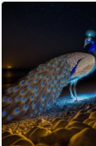
At night, when the moon is off, on the golden white sand beach, there is a beautiful peacock spreading its tail on the sparkling sand. The peacock stands on a smooth and transparent white stone, surrounded by a vast expanse of white. Smooth, transparent, ellipse, heart-shaped, crystal clear, three-dimensional transparent, galaxy, starry sky, wave, ultra-clear 8K, ultra-wide viewing angle, volumetric light, high-definition 8K image output, clear, 8K, high-definition，8k, hd HD --ar 2:3 --v 4 | 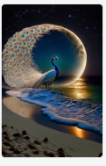
Majestic phoenix, hovering and flying over the Mountain slopes, mythical creature, conceptual art, fiery aura, beautiful, highly detailed, smoke, cinematic illumination, radiant, fantasy, swirling flames, glowing --ar 2:3 --v 4 --q 2 | 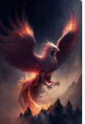
beautiful romantic snow scene, a peacock standing on a beautiful and ethereal tree full of snowflakes, many heartshaped crystal stones glittering on the snow, light purple roses, very clear and beautiful, surreal, light blue color scheme, soft and clear edges, super beautiful, super high definition, super detailed, epic cg rendering, dreamy beauty, 8k high definition HD, 16K --uplight --v 4 --ar 2:3 | 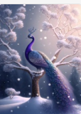
a super cute cute cute anthropomorphic fluffy little white mouse baby, white hat, wearing a pair of transparent glasses, a light blue scarf on the neck, smile, big eyes, cute, naive, high definition, real, ultradetail, edge light, 4k, hinane rendering, cg style 1 --v 4 | 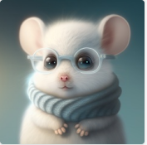
a cute little rabbit+snow-white fluffy,big bright eyes, sweet smile,sweet smile,sweet smile,dressed as a fashion model, wearing a green Crystal texture Fashion suit, hat and handbag, snowwhite fluffy,big bright eyes, bright big eyes,standing, fluffy tail, winter rising, flowers and snow gently fluttering, extremely detailed 3d animation rendering symmetrical center position, super lifelike, super detailed, luxurious, 3, movie lights, super clear details, super transparent materials, closeup, complex texture, octane rendering, zbrush, 8k, super realistic ureal --v 4 | 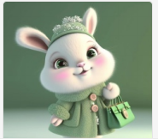
Front view, 3D, on a winter morning, small and cute humanoid white rabbit cub, wearing a cute plush hat, pink and blue school uniform, plump body, symmetrical ears, bright big eyes, sweet smile, sitting on an apple made of transparent foam gl crystals and cherry blossoms, Christmas scene, complex fur details, soft movie lighting, 16k, portrait, red cliff style, octane rendering, illusory engine rendering, high quality, Pixar ureal --ar 2:3 --v 4 --uplight --q 2 | 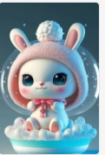
A lovely and happy Pixar style rabbit baby, wearing a checked shirt, carrying a schoolbag to school, with a sweet smile, beautiful big eyes, snow-white fluff, walking on the snow under the sun, flowers, bright colors, comfortable light, beautiful scenery, surrealism, ultra-high definition, ultra-fine, 3D, fairy tale world, three-dimensional HD, 8K, illusory engine 5, octane rendering --v 4 --q 2 | 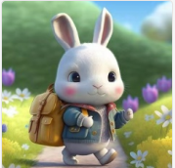
This is a CG rendering of a beautiful painting, a beautiful white peacock on the blue beach by the sea, white feathers, smooth and delicate feathers, sunshine, ultra wide Angle of view, ocean volume of sunshine light, surrealism, ultra wide Angle of view, ultra wide field of view, and ultra HD quality, 8K, high detail, octane rendering, extreme long lens, beautiful lighting, ureal --ar 2:3 --v 4 --q 2 | 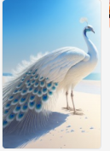
A beautiful spring scene of spring, with beautiful white peacock's glittering feathers, peach ,blossoms, flowing water, long beautiful jewelry dotted feathers. white peacock perched on branches of peach blossoms, The photography is bright and soft, with beautiful artistic conception. The ultra-high definition pictures are clear and delicate, 4K HD --ar 2:3 --v 4 | 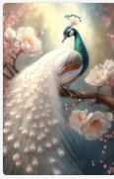
A beautiful spring scene of spring, with beautiful white peacock's glittering feathers,peony blossoms, flowing water, long beautiful jewelry dotted feathers. white peacock perched on branches of peony blossoms, The photography is bright and soft, with beautiful artistic conception. The ultra-high definition pictures are clear and delicate, 4K HD --ar 2:3 --v 4 | 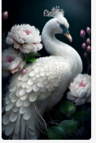
A beautiful spring scene of spring, with beautiful white peacock's glittering feathers, peach blossoms, green mountains,waterfall, flowing water, long beautiful jewelry dotted feathers. white peacock perched on branches of peach blossoms, The photography is bright and soft, with beautiful artistic conception. The ultra-high definition pictures are clear and delicate, 4K HD --ar 2:3 --v 4 | 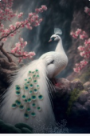
A super cute baby pixar style white fairy rabbit with smile,with two cute ears,shiny snow-white fluffy, big bright eyes, fluffy tail, Smiling and sitting on,wearing a orange hat,delicate and fine, fairy tales, incredibly high detailed, Pixar style, bright color , Natural light, Simple background with pure color,Wide Chest, Full Length Portrait,5 and Octane Render, trending on artstation, Gorgeous,ultra wide angle, 8K,hd realistic --v 4 | 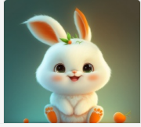
Cartoon character design,cute anthropomorphic cat, Pop mart style ,Nendoroid style,The body is polished white jade,cyberpunk ,super gorgeous,Wearing very fashionable clothes, Q,and it is as charming as chinese snowflakes lts super fine fur,Super delicate head,pink color, turquoise red eyes,Ultra-detailed scales,Ultra-fine fur texture, whole body,jewelry, complex details, chinese Han-fu,lots lights, gold design, ilusory engine, octane rendering, mad consul peter morbach, jordangrimmer, cattle atmospheric aperture, magic aperture, fantasyaperture, flame aperture, cow marks the rainbow bridge to heaven, light and dark, the corner of hell, high-definition aesthetic pictures, high-definition, 4k high-definition, ultra-highdefinition, 3d rendering, Jadeite,virtual engine, very detailed --v 4 | 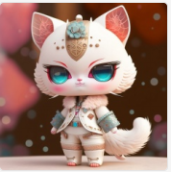
<https://s.mj.run/nxFlbIEquh4> Pixar style, Chinese New Year, a cute white rabbit, dressed in a red Chinese tunic suit, sitting on a big fish, front portrait, lanterns, firecrackers, dark red monochrome background, personification, film lighting, Chinese culture, super clear details, super clear materials, close-up, complex textures, octane rendering, zbrush, 8k, portrait，--v 4 --q 2 --ar 2:3 --v 4 | 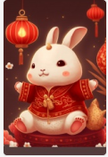
<https://s.mj.run/G7pksMsfs8I> Great prospect，big long-shot,Cute Full body image，The screen is symmetrical，Cartoon style , Chinese New Year, a cute white rabbit, Beautiful and bright eyes，dressed in a red Chinese tunic suit, sitting on a big fish, front portrait, lanterns, firecrackers, dark red monochrome background, personification, film lighting, Chinese culture,, popular illustrations, detailed lines of animation, vinyl decsl stickers, unreal engine, 8k , quality 5 --v 4 --q 2 --ar 2:3 --v 4 | 
<https://s.mj.run/DFc-FkpmA3g> Great prospect，big long-shot,Cute Full body image，The screen is symmetrical，Cartoon style , Chinese New Year, a cute white rabbit, Beautiful and bright eyes，dressed in a red Chinese tunic suit, sitting on a big fish, front portrait, lanterns, firecrackers, dark red monochrome background, personification, film lighting, Chinese culture,, popular illustrations, detailed lines of animation, vinyl decsl stickers, unreal engine, 8k , quality 5 --v 4 --q 2 --ar 2:3 --v 4 | 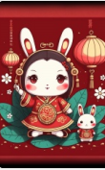
the haughty and beautiful transparent luminous peacock stands on the ethereal peace tree, the long colored tail is like glass, very beautiful pink flowers, they are transparent and crystal clear, many fireflies, the soft light is clean and transparent, surreal, dreamy and beautiful 2 --v 4 --ar 2:3 | 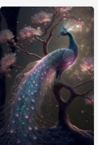
Little white bunny in cute glasses, super super cute, in cup, big eyes, surrounded by flowers, bright bedroom in background, clean sunlight, charming, fluffy, shiny mane, petals, fairy tale, Pixar style, happiness smile, anthropomorphic, trendy art station, unreal engine 5 and octane rendering, 8K, high definition, high definition real, 8k --v 4 | 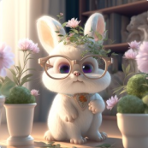
holy light, crystal little white deer baby, lovely，big eyes and long eyelashes dressed in china hanfu, lavender extremely detailed 3d animation, symmetrical center, peach blossom background, flickering, bright, super clear, transparent, focused light, optics, surrealism, magic, fantasy, composition, pink and starry sky, popular in art stations, pearl, 8k, hdq 2upbetav 4 --v 4 | 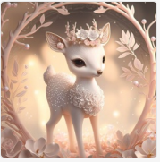
Glass artwork in the shape of a swan, filled with blue purple liquid, splashing, beautiful and noble, golden glitter, black background, twitter icon [pixiv art] [watercolor] [full body] [super fine flower feathers] [epic, frosted, High Detail, Great Wisdom, Empty, Silent, Cosmic, Spiritual, Oriental Fantasy, Multiverse, Baroque, Victorian, Epic Composition, Ornament] [Crystal, Clear, Noise Reduction, Highly Detailed, Beautiful Lighting, Cinematic Lighting] [Final fantasy, league of legends, sekiro] [trending on artstation, anime] [artwork by Krenz Cushat, Huang Guangjian, Hokusai, alphonse mucha] --v 4 | 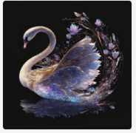
Front view, super cute Pixar-style smiling little white rabbit reading a book, wearing cute glasses, wearing a cute light pink dress + hat, smiling happily, silly, sweet smile, shiny snow white Plush, big bright eyes, fluffy tail, happy smiling faint expression, rising spring day, sweet smile, fairytale charm, Unreal Engine 5 and octane rendering --v 4 | 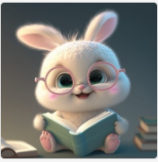
holy light, crystal little white deer, dressed in china hanfu, extremely detailed 3d animation, symmet rical center, peach blossom background, flickering, bri ght, super clear, transparent, focused light, optics, sur realism, magic, fantasy, composition, pink and starry s ky, popular in art stations, pearl, 8k, hd --ar 2:3 --v 4 | 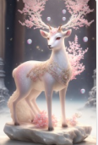
a super cute baby pixar style white fairy rabbit, shiny snowwhite fluffy, big bright eyes, fluffy tail, wearing a Navy blue sweater, wearing Navy blue a hat and sunglasses, smile,delicate and fine, fairy tales, incredibly high detailed, pixar style, bright color , natural light, simple background with pure color,5 and octane render, trending on artstation, gorgeous,ultra wide angle, 8k,hd realistic, 8k hd realistic --v 4 | 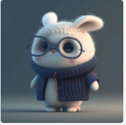
Winter morning, 3D, super cute Pixar-style white rabbit big-eyed rabbit smiles, wearing a cute strawberry plush hat, holding a strawberry, shiny snow-white fluffy, bright big eyes, with a smile, fluffy tail, fluffy snow, complete character concept, clean sunlight, art station trend, fairy tales, charming, illusory engine 5 and octane rendering urea realistic --v 4 | 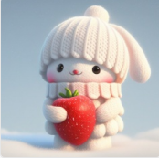
cute style, kitty drinking a bubble tea, kitty listening to music, smiling, cute, kitty wearing a headset, uplight, high resolution, lots of detail, 32k, UHD, --v 4 | 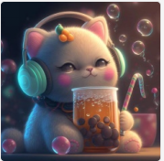
Super cute and happy fairy bunny,Wearing a red magic hat,Wearing a red Christmas dress,With many gift boxes in his hand,A tall green Christmas tree,The Christmas tree is dotted with colorful lights, and twinkling little stars,Charming big eyes, sweet smile，Fluffy, snowflakes fluttering.extremely detailed 3D animation rendering symmetrical central position，super realistic,superdetail,luxurious,cinematic lighting, super clear details, super clear material, close-up, complex texture, octane rendering, zbrush, 8K,VRAYsuper realistic --v 4 --q 2 | 
A Pixar-style cute and happy little white rabbit baby, wearing a red cotton coat and Christmas hat, a sweet smile, beautiful big eyes, snow-white fluff, standing in the snow, holding many gift boxes, pine trees covered with colorful lights, shining lanterns, comfortable light, and a starry evening,extremely detailed 3D animation rendering symmetrical central position，super realistic,superdetail,luxurious,cinematic lighting, super clear details, super clear material, close-up, complex texture, octane rendering, zbrush, 8K,VRAYsuper realistic --v 4 --q 2 | 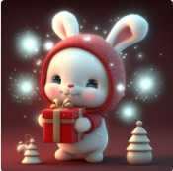
A super cute baby pixar style white fairy rabbit couple with smile,with two cute ears,shiny snow-white fluffy, big bright eyes, fluffy tail, Smiling and sitting on,wearing a red hat,delicate and fine, fairy tales, incredibly high detailed, Pixar style, bright color , Natural light, Simple background with pure color,Wide Chest, Full Length Portrait,5 and Octane Render, trending on artstation, Gorgeous,ultra wide angle, 8K,hd realistic --v 4 | 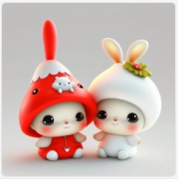
A super cute baby pixar style white fairy rabbit couple with a child，a family of three with smile,with two cute ears,shiny snow-white fluffy, big bright eyes, fluffy tail, Smiling and sitting on,wearing a red hat,delicate and fine, fairy tales, incredibly high detailed, Pixar style, bright color , Natural light, Simple background with pure color,Wide Chest, Full Length Portrait,5 and Octane Render, trending on artstation, Gorgeous,ultra wide angle, 8K,hd realistic --v 4 | 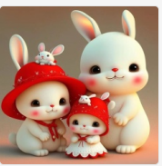
A strawberry hat, wearing cute clothes, a little white rabbit in Pixar style, a winter full of regrets, snow, sparkling snow-white fur, beautiful bright big eyes, fluffy tail, sweet smile, delicate and cute Beautiful, Fairy Tale, Incredibly High Detail, Pixar Style, Bright Colors, Natural Light, Simple Background with Solid Colors, 5 and Octane Render, Trending on Artstation, Gorgeous, Ultra Wide Angle, 8K, HD Realistic --v 4 | 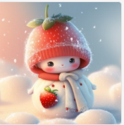
A strawberry hat, wearing lovely clothes Pixar style white snake couple, lovely big eyes, lovely smiling face, playing, very happy, fairy tale, delicate, detailed details, HD, soft light, wide Angle, clean backgroundincredibly high detailed, Pixar style, bright color , Natural light, Simple background with pure color,5 and Octane Render, trending on artstation, Gorgeous,ultra wide angle, 8K,hd realistic, 8K Hd realistic --v 4 | 