This beautiful branch, mild fairy mist, pale blue plum blossom, plum blossom, valley, snow, petals clear, snow on the petals, realistic, real, like the feeling of love, complex detail processing, HD, Dream Fairy Kingdom HD, ureal --ar 2:3 --v 4 --uplight | 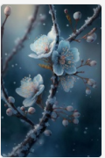
This beautiful branch, mild fairy mist, grey plum blossom, plum blossoms, valley, snow, petals clear, snow on the petals, realistic, real, like the feeling of love, complex detail processing, HD, Dream Fairy Kingdom HD, ureal --ar 2:3 --v 4 --uplight | 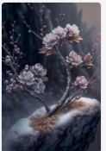
This beautiful branch, mild fairy mist, pale pink plum blossom, plum blossoms, valley, snow, petals clear, snow on the petals, realistic, real, like the feeling of love, complex detail processing, HD, Dream Fairy Kingdom HD, ureal --ar 2:3 --v 4 --uplight | 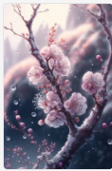
This beautiful branch, mild fairy mist, blue and orange plum blossom, plum blossom, valley, snow, petals clear, snow on the petals, realistic, real, like the feeling of love, complex detail processing, HD, Dream Fairy Kingdom HD, ureal --ar 2:3 --v 4 --uplight | 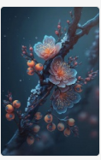
This beautiful branch, mild fairy mist, yellow and white plum blossom, plum blossom, valley, snow, petals clear, snow on the petals, realistic, real, like the feeling of love, complex detail processing, HD, Dream Fairy Kingdom HD, ureal --ar 2:3 --v 4 --uplight | 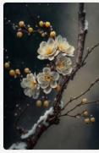
Super realistic photo of icebound roses, ten huge transparent ice cubes in the snow, red roses in the ice cubes, icebound roses, trees, outdoor, distant view, transparent, refracted light, sunlight, ultra-high definition, light smoke, melting,hyper realistic, Strong red white contrast,4K, HD ureal --ar 2:3 --v 4 --uplight | 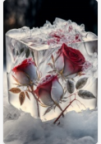
a glass block with three red roses inside of it, tumblr, neo-romanticism, beautiful winter area, incredible vfx, cubic, ice --ar 2:3 --v 4 --q 2 | 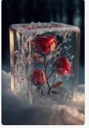
Red roses in the snow in the garden, beautiful branches, petals glistening with transparent light, gray background, crystal drops, falling reflected light, reflection, brightness, super clarity, transparent metal armor, patron saint, transparency, focusing light, optics, portrait editing, Surrealism, magic, fantasy, Compose music, pop art radio, many very small light spots, 8k, --v 4 --ar 2:3 | 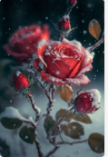
This beautiful branch, mild fairy mist, green and yellow plum blossom, plum blossom, valley, snow, petals clear, snow on the petals, realistic, real, like the feeling of love, complex detail processing, HD, Dream Fairy Kingdom HD, ureal --ar 2:3 --v 4 --uplight | 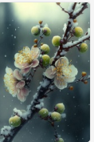
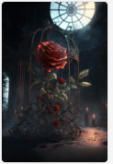 | Super wide angle view, red rose icebulerosegarden + beautiful paintings in the factory area, tall factory with many iron frames, iron nets, factory lighting, Greg ratkowski, night, a little red rose on the iron frame, art station trend, low light, smoke, steel support, volume lighting, UE4, ZBrush, marmoset Kit HD --ar 2:3 --v 4
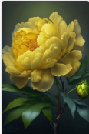 | One is a bright yellow peony flower. Petals are as deep as sea and sky, and there are many green leaves on flower branches like dew. It can feel the loyalty and purity of love,HD,ureal --ar 2:3 --v 4 --uplight
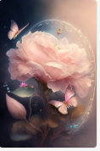 | This is abeautiful light spectrum flower,mild fairy mist light pink Chinese rose,transparent petals,petals clear butterflies fly around Chinese rose,realistic,real,like the feeling of love,complex detail processing,HD,Dream Fairy Kingdom HD,ureal --ar 2:3 --v 4
 | A high-definition transparent CG rendering, sunset,pink and red,yerrow roses, green leaves, many colorful butterflies flying. Complex Details, Ultra HD Image Quality Details, Shocking Panoramic Photography, 3D, CG Value Rendering, Soft Light Effects, HD, 8K Image HD --ar 2:3 --v 4
Snow scenery, morning fog, crystal clear, red ice roses growing in snow and benches rendered by super CG. Red ice rose petal with frost, orange light, snow scene, ultra-high detail, ultra-high definition, ultra-wide angle, reality, panorama, 8k, lifelike, 3D high pixel, landscape photography, shot by mark adams HD --ar 2:3 --v 4 | 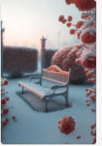
Many red roses covered with transparent snow red roses. snow red roses in the landscape of suzhou clical garden in china,red clear snow red roses ,serenity , beauty , high detail, soft moonlight, soft color, soft lighting, 8k ,new happiness, deep detail, clear level of detail, high picture quality, high definition, new love rendering hd ureal --ar 2:3 --v 4 --uplight | 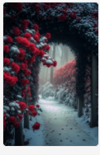
close-up a red roses covered with transparent snow red roses in the landscape of suzhou clical garden in china,red clear snow red roses ,serenity , beauty , high detail, soft moonlight, soft color, soft lighting, 8k ,new happiness, deep detail, clear level of detail, high picture quality, high definition, new love rendering hd ureal --ar 2:3 --v 4 --uplight | 
Many red roses covered with transparent snow red roses. snow red roses in the landscape of suzhou clical garden in china,the sunset，Yellow sunshine red clear snow red roses ,serenity , beauty , soft moonlight, soft color, soft lighting, 8k ,new happiness, deep detail, clear level of detail, high picture quality, high definition, new love rendering hd ureal --ar 2:3 --v 4 --uplight | 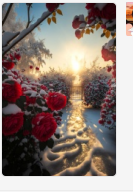
Beautiful orange, pink and white rose branches with bright light shining in the stamens, beautiful full moon in the distant sky, jingling lights, lighting effects, low light, surreal and super detailed, colorful, 8k, art station trend, can feel the loyalty and romance of love, fantasy, ray tracing, depth of field, vitality, gorgeous lights, octane rendering --ar 2:3 --v 4 --uplight | 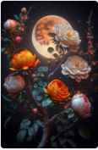
Beautiful green, pink and white rose branches with bright light shining in the stamens, beautiful full moon in the distant sky, jingling lights, lighting effects, low light, surreal and super detailed, colorful, 8k, art station trend, can feel the loyalty and romance of love, fantasy, ray tracing, depth of field, vitality, gorgeous lights, octane rendering --ar 2:3 --v 4 --uplight | 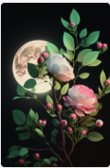
Beautiful red, blue and white rose branches with bright light shining in the stamens, beautiful full moon in the distant sky, jingling lights, lighting effects, low light, surreal and super detailed, colorful, 8k, art station trend, can feel the loyalty and romance of love, fantasy, ray tracing, depth of field, vitality, gorgeous lights, octane rendering --ar 2:3 --v 4 --uplight | 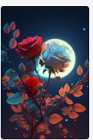
Beautiful pink, blue and white rose branches with bright light shining in the stamens, beautiful full moon in the distant sky, jingling lights, lighting effects, low light, surreal and super detailed, colorful, 8k, art station trend, can feel the loyalty and romance of love, fantasy, ray tracing, depth of field, vitality, gorgeous lights, octane rendering v --ar 2:3 --v 4 | 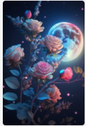
<https://s.mj.run/tpEes1j6YjQ> At night, magnolia is full of branches, white magnolia, moon, ultra HD, HD --ar 2:3 --v 4 | 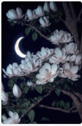
Photographic realism, there are many red roses on the snow-covered seaside, roses inserted in the snow, roses are covered with heavy snow, and very many roses extend far away. Beautiful sunset glow, romanticism, red roses are bright and vivid. Spectacular scenes, popular on art stations, 8K, high-resolution, unreal engine, long lens, soft lighting, --ar 2:3 --v 4 | 
<https://s.mj.run/tpEes1j6YjQ> At night, white magnolias are blooming all over the branches, the moon, and ultra-high definition,hd ureal --ar 2:3 --v 4 | 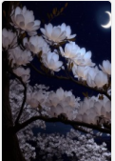
<https://s.mj.run/k6ylNRUTrQI> At night, white magnolias are full of branches, dense white magnolias, distant view, moon, ultra-high definition, high-definition, --ar 2:3 --v 4 | 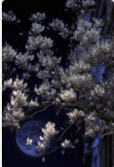
<https://s.mj.run/tpEes1j6YjQ> At night, white magnolias are blooming all over the branches, the moon, and ultra-high definition,hd ureal --ar 2:3 --v 4 | 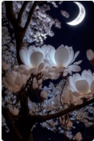
Red tile and white wall,closeup of a persimmon tree covered with transparent snowy red persimmons, in the landscape of classical garden in theImperialPalace, China, with clear red snowy persimmons, peaceful, beautiful, high detail, soft moonlight, soft colors, soft lighting , 8k, new happiness, deep detail, clear level of detail, high quality, high definition, new love rendering HD --v 4 --ar 2:3 | 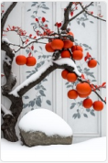
The picture is transparent, a purple crescent moon color is scattered on the beach, blue glass roses float on the beach, with heart-shaped galaxy stars, stars shine on glass roses, glowing, silver, OP art/optical art, HD 4K Vray, ultra-wide angle, illusory engine HD --v 4 --ar 2:3 | 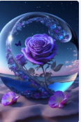
this is a romantic photo, using a brush to paint a pale red erflies that gradually turn into red plum blossoms on the canvas the background of the artboard is slightly sunny, soft, clean, transparent, 3d, atmospheric, 3d, ultrahigh definition, ultradetail, cg rendering, 3d effects, 8k, 3d matte painting by justin gerard, art station 4k, atmospheric lighting --v 4 | 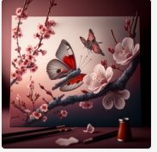
Outside the window, A huge white magnolia tree in the corner of the city is full of white magnolias ,Traditional Landscape of Jiangnan Ancient Town in China,8kUltra clear, transparent, caustic, optical, surreal, composition, dark, trend on art station, pearl, 8k, hd --ar 2:3 --v 4 | 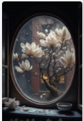
snow scenery, morning fog,sunny,white background, white background,white background,gorgeous red and pink Dandelions garden,created by krenzu cschart relseiy miho, 4k hd --ar 2:3 --v 4 | 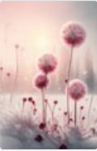
snow scenery, morning fog,sunny,white background, white background,white background,gorgeous red and pink tulips garden,created by krenzu cschart relseiy miho, 4k hd --ar 2:3 --v 4 | 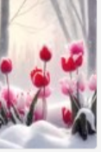
snow scenery, morning fog,sunny,white background, white background,white background,gorgeous red tulips garden,created by krenzu cschart relseiy miho, 4k hd --ar 2:3 --v 4 | 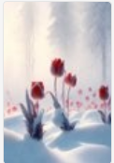
A holographic lotus flower in a lake at night with fireflies and a stary sky, made by Katsushika Hokusai, ukiyo-e style, highly-detailed, close up, --v 4 --q 2 --ar 2:3 | 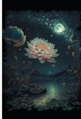
magnolia flower, magical, ethereal, holographic gossamer --v 4 | 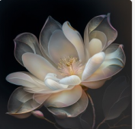
Photograph of Snow, morning fog, fine, white background, white background, white background, gorgeous red peony garden, created by Krenzu Cschart Relseiy Miho --ar 2:3 --v 4 | 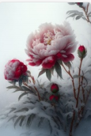
Beautiful pink and white Dandelions branches with bright light shining in the stamens, beautiful full moon in the distant sky, jingling lights, lighting effects, low light, surreal and super detailed, colorful, 8k, art station trend, can feel the loyalty and romance of love, fantasy, ray tracing, depth of field, vitality, gorgeous lights, octane rendering --v 4 --ar 2:3 | 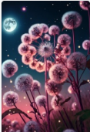
Beautiful pink and white Dandelions branches with bright light shining in the stamens, beautiful full moon in the distant sky, jingling lights, lighting effects, low light, surreal and super detailed, colorful, 8k, art station trend, can feel the loyalty and romance of love, fantasy, ray tracing, depth of field, vitality, gorgeous lights, octane rendering --v 4 --ar 2:3 | 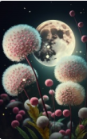
Beautiful orange and white Dandelions branches with bright light shining in the stamens, beautiful full moon in the distant sky, jingling lights, lighting effects, low light, surreal and super detailed, colorful, 8k, art station trend, can feel the loyalty and romance of love, fantasy, ray tracing, depth of field, vitality, gorgeous lights, octane rendering --v 4 --ar 2:3 | 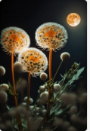
Beautiful blue and white Dandelions branches with bright light shining in the stamens, beautiful full moon in the distant sky, jingling lights, lighting effects, low light, surreal and super detailed, colorful, 8k, art station trend, can feel the loyalty and romance of love, fantasy, ray tracing, depth of field, vitality, gorgeous lights, octane rendering --v 4 --ar 2:3 | 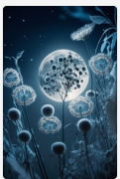
This is a beautiful spectral flower with a soft fairy tale fog background, light smoke, rose color, blue roses, transparent petals, clear, lifelike, real petals, feeling like love, complex details processing, perspective, high definition, high definition of the dream fairy tale kingdom, urea,8k --ar 2:3 --q 2 --upbeta --v 4 | 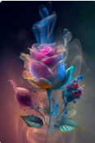
This is a romantic snow scene with many blue roses in the snow. Morning sun, light sunlight in garden background, soft, clean, transparent, 3D, atmospheric, ultra-high-definition, ultra-detailed, CG rendering, 3D effects, 8K, wide angle shot by Richard Schmidt and Sargent, quiet, white, gentle, health, minimalism, light and shadow, beauty, in cgsociety, idealism, white negative space, white and blue hd, 8K, urea formaldehyde --ar 2:3 --v 4 | 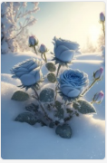
Dreams and fairies fly to the Moon Mid-Autumn Festival Chinese elegant white lotus + serenity + aestheticism + high detail, soft moonlight, soft colors, soft lighting, 8k new happiness, deep details, layered details, high quality, high definition and new love rendering HD --ar 2:3 --v 4 --q 2 | 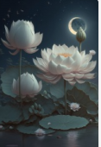
this is a romantic photo, using a brush to paint a pale red erflies that gradually turn into yellow plum blossoms on the canvas the background of the artboard is slightly sunny, soft, clean, transparent, 3d, atmospheric, 3d, ultrahigh definition, ultradetail, cg rendering, 3d effects, 8k, 3d matte painting by justin gerard, art station 4k, atmospheric lighting --ar 2:3 --v 4 | 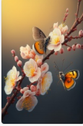
this is a romantic photo, using a brush to paint a pale red erflies that gradually turn into white plum blossoms on the canvas the background of the artboard is slightly sunny, soft, clean, transparent, 3d, atmospheric, 3d, ultrahigh definition, ultradetail, cg rendering, 3d effects, 8k, 3d matte painting by justin gerard, art station 4k, atmospheric lighting --ar 2:3 --v 4 | 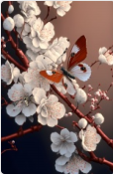
this is a romantic photo, using a brush to paint a pale red erflies that gradually turn into red plum blossoms on the canvas the background of the artboard is slightly sunny, soft, clean, transparent, 3d, atmospheric, 3d, ultrahigh definition, ultradetail, cg rendering, 3d effects, 8k, 3d matte painting by justin gerard, art station 4k, atmospheric lighting --ar 2:3 --v 4 | 