It is a surreal and complex cg rendering of transparent, pink butterflies flying to heaven, blue light shining on the snow, cq3d effects body light sky, ultra wide angle blue reflection, blue sky, influence complex details of super shock reality 8k, real life Mark Adamus landscape photography Stereo light, symmetric, depth of field, 8k HD 8k, HD --ar 2:3 --v 4 | 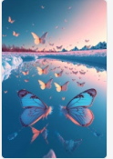
It is a surreal and complex cg rendering of transparent, orange butterflies flying to heaven, blue light shining on the snow, cq3d effects body light sky, ultra wide angle blue reflection, blue sky, influence complex details of super shock reality 8k, real life Mark Adamus landscape photography Stereo light, symmetric, depth of field, 8k HD 8k, HD --ar 2:3 --v 4 | 
It is a surreal and complex cg rendering of transparent, pink butterflies flying to heaven, blue light shining on the snow, cq3d effects body light sky, ultra wide angle blue reflection, blue sky, influence complex details of super shock reality 8k, real life Mark Adamus landscape photography Stereo light, symmetric, depth of field, 8k HD 8k, HD --ar 2:3 --v 4 | 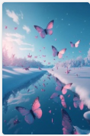
This is a romantic picture, A light lilac butterfly is painted on the canvas, with a brush. The background of the drawing board is slightly sunny, soft, clean and transparent, three-dimensional, atmospheric, 3D, ultra-high-definition, super-detail, CG rendering, 3D effect, 8K, 3d matte painting by Justin Gerard, artstation 4k, atmospheric lighting --ar 2:3 --v 4 | 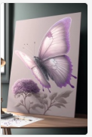
A huge persimmon tree in the corner of the city is full of red persimmons. The persimmons are covered with snow. The traditional landscape of Jiangnan ancient town is quiet, beautiful, high detail, soft moonlight, soft color, soft light, 8k, new happiness, deep details, clear level of detail, high quality, high definition, new love rendering,HD --ar 2:3 --v 4 | 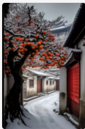
Winter night, idyllic scenery, wheat fields are covered with a layer of white snow, trees without leaves, Hayao Miyazaki, Xinhaicheng creation, 8k, super wide angle, soft light, fairy tale, high-definition wallpaper --ar 2:3 --q 2 --upbeta --v 4 | 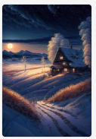
Beautiful and romantic snow scene, delicate and beautiful snowflakes condensed into crescent shape with moon halo, There is a fairytale snow house with lights on the snowflake path，lights, many heart shaped crystal stones shining on the snow, light gold rose, very clear and beautiful, surreal, light gold color scheme, Soft and clear edges, lighting effects, ultra-beautiful, ultra-high-definition, ultra-detailed, epic CG rendering, dreamy and beautiful, 8k --ar 2:3 --v 4 --upbeta | 
beautiful rolling green hills overlooking mountains and villages in rural Japan Studio Ghibli --v 4 --q 2 --ar 2:3 | 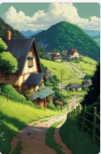
 | It is a surreal and complex cg rendering of transparent, white butterflies flying to heaven, blue light shining on the snow, cq3d effects body light sky, ultra wide angle blue reflection, blue sky, influence complex details of super shock reality 8k, real life Mark Adamus landscape photography Stereo light, symmetric, depth of field, 8k HD 8k, HD --ar 2:3 --v 4
 | this is a snow scene in a beautiful fairy tale, there is a huge transparent c shape and a happy snowman on the baby purple and white snow, and the christmas gift under the christmas tree is in love bright colors, through love, through the c shape you can see the back of the snow scene, a snow trail leads to a refined baby purple and green cottage, villa lights, and some pink plump love roses, its very romantic, super clear, wide angle, dream engine 8k high definition --ar 2:3 --v 4
 | This is a beautiful digital art snow scene. There is a huge transparent love on the purple and white snow surface. Through the love, you can see the snow scene behind. There are some white English letters“ love” in the love. It is extremely romantic, super clear, wide angle, dream engine. 8K HD --ar 2:3 --v 4
 | This is a beautiful digital art snow scene. There is a huge transparent love on the purple and white snow surface. Through the love, you can see the snow scene behind. There are some white English letters“ love” in the love. It is extremely romantic, super clear, wide angle, dream engine. 8K HD --ar 2:3 --v 4
 | Frozen hyperrealistic photos, close-up of transparent ice in the snow, frozen pirate ship, frozen pirate ship, outdoors, farsight, transparent, refraction light, symmetry, sunlight, Ultra HD, ultra realistic, strong clear contrast, 4K, HD --v 4 --ar 2:3
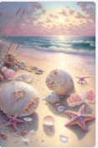 | a cg rendering of many beautiful pale pink large shells and pale pink conch shells on the beach with a ring of sparkling rosettes, as crystal clear as glass the moonlight shines on the snowwhite beach, the blue sea, pearls, super details, fireflies, light effects, fairyland romance 1 by thomas kinkade, krenz and victo nagi, cgsociety trends, soft light, super wideangle, distant view, fairy tale, fantasy, 8k hd wallpaper 1 piece, oversaturation, people, signature, blur, depth of field --v 4 --ar 2:3
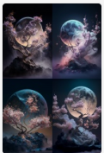 | Yoshizaka Moon Valley Smoke Sculpture Delicate plum blossom, filamentous, aurora, celestial, subtle, dreamy, ethereal, fantasy, art photography, moonlight hours 8k hd --ar 2:3 --v 4
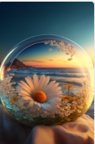 | A high-definition transparent CG rendering, a round big sunset covering the light blue sea, a yellow and white daisy on the beach, yellow and white daisies can feel its love and purity in winter. Complex details, ultra-high definition image quality details, shocking panoramic photography, 3D, CG value rendering, soft light effect, high-definition, 8K image HD --ar 2:3 --v 4
beautiful and romantic snow scene, delicate and beautiful snowflakes condensed into a heart shape, with a moon halo, a pair of swans standing opposite each other there are lights, lights, many heartshaped crystals shining on the snow, light golden roses, very clear and beautiful, background blue the sea is covered with ice and snow, surreal, light red color scheme, soft and clear edges, lighting effects, super beautiful, super high definition, super fine, epic cg rendering, dreamy and beautiful, 8kar 23v 4upbeta 1 --v 4 | 
Pictures are diamond-studded transparent crescent moon scattered on snow, a beautiful cottage in transparent Crescent, winter, snow, Christmas atmosphere, red roses heart shaped Milky Way stars floating on the beach Stars surrounded by roses and depth of field Baby, various colors, silver, op Art Optical Art, HD 4k vray, Ultra Wide Angle, Unreal Engine HD,ureal --ar 2:3 --v 4 --uplight | 
Romantic blue ocean, sparkling snow beach, violet roses on the beach, dark blue love shaped beach, and two white swans in the water. Lover's embrace, purple heart cloud, Milky Way, meteor, many glittering small creatures, pink and purple rose crystals, Maldives, tundra, iceberg, fantasy, high detail, 8K, octane rendering, lifelike, complex details, ultra wide viewing angle, panoramic lens, volume light，HD 8K, 16K HD picture HDHD,ureal --ar 2:3 --v 4 | 
This beautiful tree branch , fog, with white and white，morningsunlight， flowers, plum blossoms, mountain valley,chinese old house,snow,high definition, dream fairy kingdom HD,ureal --ar 2:3 --v 4 --upbeta | 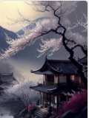
fantasy, cloud winding background, hd midautumn festival chinese elegant plum blossom tranquility aestheticismhigh details, soft moonlight, soft colors, soft lights,8k new happiness, deep details,distinct levels of detail,high picture quality,high definition and new huan renderin,8k hd --v 4 --ar 2:3 --q 2 | 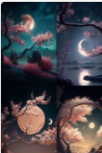
A surreal ancient Chinese CG rendering, waterfalls, rivers, pavilions, Bridges, cherry blossoms, ancient trees, white petals flying all over the sky, winter, moon, glowing fog, vertical, clean picture, detail, super clear, 8K, volume lighting, volume light, soft light, Unreal Engine, octane rendering, super wide perspective,ureal --ar 2:3 --v 4 --upbeta --q 2 | 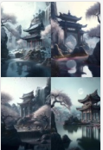
At night, the bright moonlight sprinkled on the sea, like countless pieces, causing ripples. I listened quietly to the sound of the waves of the sea, and countless thoughts flocked to my mind. The beautiful moonlit night and the sound of the waves kept me awake for a long time. --v 4 --ar 2:3 | 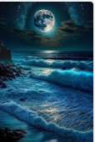
Surreal landscape shot of white snow and a golden tree, movie in the wind, night, crescent moon, country yard, glowing stars, 8K, --ar 2:3 --v 4 | 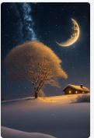
jiangnan water town, trees, rivers, on both sides of the river are jiangnan houses, there are boats, people on board, there are kapok, galaxy, fireflies, star river,16k,made of crystal,high resolution,rendered in octane,depth of field dof,beautiful lighting, ar 916 upbeta 2,,ureal --ar 2:3 --v 4 | 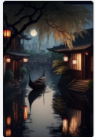
Christmas art,Holiday,New year tree --q 2 --ar 2:3 --v 4 --v 3 | 
CG rendering of many beautiful light green shells + light blue conch shells + blue starfish shining on the beach, heart-shaped roses, crystal clear gl moonlight on the snow-white sand, blue sea, pearls, super details, fireflies , Lighting Effects, Wonderland Romance 1 by thomas kincaid, krenz and victo nagi, cgsociety trends, glare, super wide angle, vista, fairy tale, fantasy, 8k hd wallpaper 1, suoversaturated, people, signature, blur, dof --v 4 --ar 2:3 --v 3 | 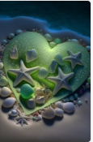
forest, blue, glowing butterflies, mild fog, moonlight, ultra realistic 8k --ar 2:3 --v 4 | 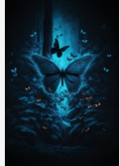
A large American Christmas tree, festive atmosphere, bright and warm, glowing dynamic particles suspended around the Christmas tree, volumetric lighting, ray tracing, Ghibli Studio style --ar 2:3 --v 4 | 
Outside the window, have a heavy snow,A huge white magnolia tree in the corner of the city is full of white magnolias ,Traditional Landscape of Jiangnan Ancient Town in China,8kUltra clear, transparent, caustic, optical, surreal, composition, dark, trend on art station, pearl, 8k, hd --ar 2:3 --v 4 | 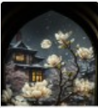
Sunset slanting, snow falling in winter, soft fairy fog, red rose garden scenery, roses, hammocks on trees, snow, clear petals, snow on petals, lifelike, real, like the feeling of love, complex details, distant trees, high-definition, dream fairylands, high-definition, dream fairyland, super clear, wide angle, dream engine 8k high-definition in love, urea, high-definition,real,HD --v 4 --ar 2:3 | 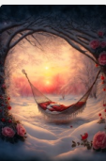
a beautifuland ethereal,pink,rainbow,and sparklingpastelpunk peace tree on a magical celestial book,high definition,dreamy,surrounded bysparkling ice crystals,--v 4 | 
Summer, seaside, white sand with many colorful daisies, love confession, roses, transparent white opal pebbles, smooth, color, glow, transparent, far sea, sunshine, depth of field, all kinds of colors, super realistic, HD, 8k, Unreal Engine 5 --v 4 --ar 2:3 --q 2 | 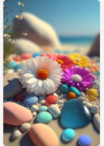
Summer, seaside, on the beach, transparent pebbles, transparent, glowing, colorful 8K,hd --ar 2:3 --v 4 | 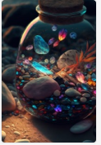
Insummer,bythesea,there are manywhite daisies onthe white sand beach,roses,transparent empty opal pebbles, smooth,colorful,luminous,transparent:thesea in the distance,sunny,depth of field,various colors,super realistic,high-definition,8k,illusoryengine,ureal --ar 2:3 --v 4 | 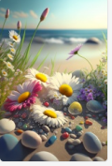
Early morning, morning sunshine, beautiful photo of Jiangnan ancient town, sunny, roses blooming on both sides of the street, 8k ultra-clear, transparent, caustics, optics, surreal, composition, darkness, trends on Art Station, pearls, 8k, high-definition --ar 2:3 --v 4 | 